# 

#### 



**Request for Information**

**Strategic System Selection**

**(Innovation)**

**Andor Health Proposal**

**Table of Contents**

1. Executive Summary

**Summary of your understanding of Beebe’s system objectives and how your proposed solution will meet these objectives.**

Based on our understanding of the requirements, Beebe Healthcare has a strategic plan aimed at delivering exceptional healthcare to Sussex County communities. To achieve this vision, Beebe recognizes the importance of a robust and integrated information technology (IT) ecosystem, referred to as *One Beebe*, which will benefit patients, families, providers, and staff. The current IT ecosystem requires significant enhancements to align with Beebe's strategic plan, support its growth and development over the next 3 to 5 years and beyond, and adapt to the future of healthcare.

Beebe's executive leadership acknowledges that the organization's position as an independent regional healthcare system relies heavily on the capabilities of its IT ecosystem. While some components of the current system have been in place for an extended period, they may have shortcomings. To leverage the potential of new disruptive technologies that can enhance Beebe's capabilities, it is crucial for Beebe to proactively enhance its IT ecosystem.

Therefore, Beebe seeks to incorporate innovative technologies that can act as catalysts for transformative healthcare change, leading to a distinctive One Beebe experience for both patients and providers. Beebe expects these innovations to be easily accessible not only to their known patients and providers but also to the wider community, enabling broad engagement with One Beebe healthcare and services.

**Brief summary of the proposal in non-technical terms.**

Andor Health is delighted to respond to the RFI titled Strategic System Selection - Innovation. We are eager to demonstrate our ability to meet and exceed the requirements as defined in the RFI by Beebe Healthcare.

Andor Health was born 4 years ago with a single mission; to fundamentally change the way in which care teams, patients, and families connect and collaborate. By harnessing the latest innovations in OpenAI/ChatGPT and transformative generative AI/ML models, our cloud-based platform unlocks data stored in source systems, such as electronic medical records, to deliver real-time actionable intelligence to care teams within ubiquitous care team collaboration platforms like Microsoft Teams. By perfecting communication workflows, our platform accelerates time to treatment, decreases clinician burnout, and drives better patient outcomes.

For over 20 years, our leadership team has placed intense focus on pioneering technologies for patients, creating more collaborative experiences for clinicians, using innovative devices, and driving evolution to mobile self-service. Healthcare institutions and care teams use ThinkAndor® to enable providers to configure patient and clinician interactions with ubiquitous team collaboration platforms. This eliminates the need to manage added applications. ThinkAndor® enables a frictionless virtual interaction allowing physicians and patients to communicate without being distracted by disjointed technologies during a virtual consultation. ThinkAndor is the only integrated virtual collaboraiton platform that can truly integrate all aspects of ambulatory, acute, post-acute and at home virtual care collaboration through our 5 Pillars of Virtual Health: **Virtual Visits, Virtual Rounding, Virtual Patient Monitoring, Virtual Team Collaboration, and Virtual Community Collaboration**.

Andor Health is partnered with over 40 health systems across the US, Uk, and Canada, with over 70,000 providers and 300 hospitals leveraging the Andor Health platform globally, and ThinkAndor is the only virtual collaboration platform deployed AT SCALE. National Institutes of Health, Orlando Health, Tampa General, Medical University of South Carolina, and NHS, are among some of the most notable. You may find a list of our strategic partners by accessing this [link](https://www.andorhealth.com/partners.html). Moreover we have several distinct strategic partnerships and integrations, we have integrated to multiple EMR’s including being a top tier partner Epic Connection Hub (App Orchard) partner, Cerner (CODE development partner), and Athena MDP partner which allow ThinkAndor to discretely integrate data and workflows to remain fundamentally aligned with any back end data sources at Beebe and retain consistent workflows for care teams.

**Overall scope of the proposed system(s) and services.**

Andor Health’s mission is to fundamentally change the way in which care teams, patients, and families connect and collaborate. By harnessing the latest innovations in AI and ML, our ThinkAndor Virtual Care Collaboration Suite allows healthcare institutions to quickly configure care team workflows and virtual health experiences leveraging ubiquitous collaboration platforms like Microsoft Teams. By optimizing collaboration and communication workflows, our platform helps healthcare systems increase access to care to patients, accelerate time to intervention, improves clinician productivity and scales clinical resources, and drives better patient outcomes.

The ThinkAndor Virtual Care Collaboration Platform brings clinical orchestration and coordination across 5 key pillars of Virtual Health; [Virtual Health Enablement](https://andorhealth-my.sharepoint.com/:b:/p/pierre_pacini/EaB8G9xwj01GlJyg4tcpwmgBb8Ko_nWeDn1fAbK0Aq73MA?e=R7VVCH), [Virtual Rounding](https://andorhealth-my.sharepoint.com/:b:/p/pierre_pacini/EXHIcIKSa99Hrzl1IUcDpQsB3bskxcPxNapVAEkm29M5fQ?e=yDfAUn), [Virtual Patient Monitoring](https://andorhealth-my.sharepoint.com/:b:/p/pierre_pacini/EQaCQqPPkF9NjjtQBWu1LRMBq6PIvprmEMBx8b45FFZPig?e=z0J3bx), [Virtual At Home Monitoring](https://andorhealth-my.sharepoint.com/:b:/p/pierre_pacini/EQaCQqPPkF9NjjtQBWu1LRMBq6PIvprmEMBx8b45FFZPig?e=z0J3bx), and [Vir](https://andorhealth.sharepoint.com/:b:/s/SalesProduct/EVonbqrhRx5GpIg8PqUptDEBuGY46psNlrtTUYPr7c2Teg?e=CQcGed)tual Team Collaboration. Designed with a proprietary role-based hierarchy and enterprise taxonomy, plus Digital Front Door experiences for both the patients and care team, healthcare systems can automate highly efficient workflows that empower clinicians in virtual care delivery. At Andor Health, we believe this ‘virtual clinical integration layer’ is the crux to solving the most impactful challenges facing healthcare institutions.

The result is a frictionless, engaging, and positive virtual interaction allowing physicians and patients to communicate without being distracted by disjointed technology solutions that are often part of a virtual consultation.

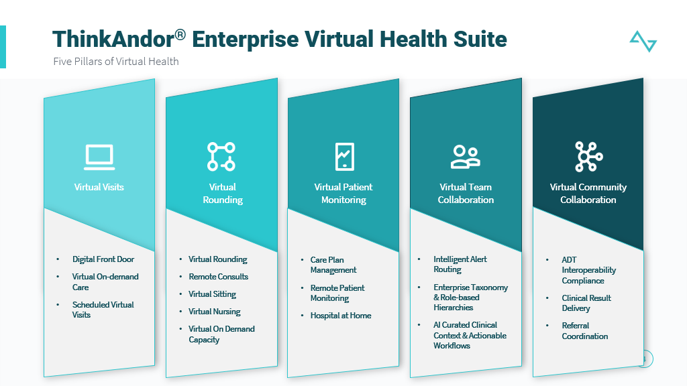

**System capabilities and Key Differentiators**

ThinkAndor brings providers the next generation of clinical communication and collaboration tools that automates just-in-time communication and collaboration across an enterprise ultimately driving enhanced care coordination, care team efficiency, and accelerated decision- making to improve overall patient outcomes. ThinkAndor allows for customized communication channels that ensure an immediate and automatic connection to the correct provider, ensuring meaningful and effective collaboration. Some key differentiators include:

* OpenAI/GPT: Andor Health is the first to pioneer OpenAI/GPT models to orchestrate clinical workflows in a platform approach across all lines of service outpatient, inpatient, and at home experiences. This platform approach allows organizations to unify their virtual experiences under a single pane of glass allowing the ThinkAndor AI Virtual Assistant to curate the right workflows, to the right participants, with the right clinical context for service delivery. In addition, ThinkAndor acts as a participant in any virtual session that can stage and curate clinical content from the EHR for the providers, provide an ambient experience for clinicians to request content on demand, and allow for full AI driven SOAP note generation that can be pushed back to the EHR for documentation and billing.
* Role Based Hierarchy: Andor Health is designed with an enterprise taxonomy and role based hierarchy that allows for the ability to configure workflows for clinical alerts such as Sepsis or MRSA, as well as remote consult requests such as TeleStroke, TelePsych, Virtual Nurse, Virtual Sitters, or other specialties. By ingesting/managing shift schedules from platforms such as Qgenda, AMION, ThinkAndor can send notifications to the appreciate care teams based on the data signals that have been identified.
* No Code/Low Code Configuration: ThinkAndor Platform is built on an IFTTT framework that offers a configuration utility to rapidly configure roles, care teams, and workflow experiences for patient and care teams without the need for code development. This provides for rapid implementation and deployment of workflows across the enterprise
* Configurable Digital Front Door: Alongside the vitual command center for clinicians and care teams, ThinkAndor also offer a comprehensive Digital Front Door for patient population to easily interact with the health system. With ThinkAndor’s Digital Front Door, Beebe can configure Adaptive Triage models with line of service navigation, patient self scheduling, configurable virtual waiting rooms for both virtual and onsite care environment to capture intake, assessments, consents, payments, education, and other workflow experience pre and post visit.
* Pluggability/Extensibility with Hardware Agnostic Design: ThinkAndor is an open architecture platform that allows for easy pluggability of other platform capabilities both at a software and hardware level. For Virtual Rounding, Andor Health can allow for any in room devices to be leveraged by Beebe and will seamlessly plug into the ThinkAndor Platform. For Remote Patient Monitoring, Andor Health allows for any set of devices to be leveraged by the patient population to monitor at home.
* Technology plus Services: Andor Health is the first to pioneer a full services ecosystem alongside our highly rated technology platform. With the shortages in clinicians and nurses occurring across the industry, Andor Health has been able to establish partnerships with other health systems and providers that use our technology and have unique capacity and skill sets where other health systems may have a gap. As a result, Andor Health can also bring virtual nurses, virtual sitters, specialty clinicians such as hospitalists, nocturnists, psychiatry, neurology, and many other specialities to help provide burst capacity to Beebe when in need.
* Platform Based Approach: Andor Health fundamentally believes that clinician burnout can be reduced by reducing the disparate, silo’d technologies used for independent use cases. With one platform, clinicians and care teams now have a virtual command center that provides and curates specific views and actions across all lines of virtual care; outpatient, inpatient, and at home.

|  |  |  |
| --- | --- | --- |
|  | **Service Description** | **Value Proposition** |
| ThinkAndor Enterprise Platform | **Enterprise approach to all virtual health modules:** Digital Front Door, Virtual Health, Virtual Patient Monitoring, Virtual Rounding, Virtual Teams Collaboration, Virtual At Home | Virtual health platform consolidation- average health systems can save nearly $3M+ or over 60% in existing software costs |
| Digital Front Door | **Digital front door with AI Virtual Assistant framework accessible on any channel including SMS Text, Email, Web, AI chat bot**     * Enable intake/triage forms for self-reported data and patient navigation * Configure automated patient experience workflows for marketing, scheduling, and other clinically relevant opportunities * End to end digital front door experience for virtual visits as well as in person visits * Configuration of CRM platform of choice for workflows | * Reduce unnecessary ED visits by 55% and increase in Virtual Urgent/Primary Care      * 35%-40% more gap closures      * Reduce abandonment rates by 20%      * 30% increase in enrollments to programs such as patient portal, clinical research, and RPM |
| Virtual Health Enablement | **Comprehensive end- to-end Virtual Health Configuration**    Distributed workflow orchestration and meeting management by ThinkAndor Virtual Assistant    **Patient Virtual Waiting Room**   * Patient notifications & Pre- visit * Virtual lobby, assessments, digital consents, eligibility & payments * Program & Portal enrollment * Education, videos, family invitations, call back feature   **Clinical Notification & Dashboard Views**   * EHR integrated experience * Provider visibility & virtual lobby access * Automated waiting room queues for on demand and scheduled patients * Automated notifications and alerts to next care team member to ‘join’ session * Embedded in Virtual collaboration & EHR platforms (enables providers to curate content from EMR into the visit experience) | * 30% reduction in call abandonment rate      * 95%+ success in virtual visit completion      * 8-12 minutes of staff time saved per visit.     Increase clinical staff capacity by 3x. |
| Virtual Rounding, Nursing, Sitting, & Specialty Consults | **Rounding experiences for Inpatient bedside and remote patient monitoring**     * In room & remote device provisioning * Simplified single click join experience for participants with WebRTC enablement. * AI virtual assistant for patient self- reported intelligence * IoMT, PTZ camera, and diagnostic device integration * Automated care team notification and inter- discipline collaboration * Enable automated signals and alerts to care coordinators and nurses. * Multi-disciplinary collaboration sessions with patients and families * Orchestration of tele consultation workflows * Orchestrate automated care plan follow up. * Patient experience assessments, including Q15 Check in * Care teams can continuously monitor at-risk patients ensuring clinicians are able to intervene when patients need help most * Remote in Specialist: Neurology, Cardiology, Psychology, etc. | * Increased productivity of clinical and admin staff by 3x * Increased physician satisfaction * 23% increase in patient satisfaction scores * Reduction in Left Without Being seen of 36% * Average Bed to Disposition time reduction of ~18 minutes per patient * Reduced operational costs by 30% * Increased staff resource capacity by 4x * Reduced operational costs by 30% * Increased staff resource capacity by 3x * Reduced time to intervention by 40% |
| Virtual Patient Monitoring | * Unified experience for VPM enrolled patients with an efficient workflow for care teams and clinicians. * Patient device kits and self-reported assessments integrated with workflow orchestration where care team members can configure distinct data signals to monitor patients remotely * Configurable, AI Driven care plan templates * Routine patient check-ins / assessments * Integrated asynchronous/sync hronous virtual visit experiences for interventions and routine patient follow up | * Avg 24% decrease in readmission rates      * Increase care plan compliance post discharge by 30%      * 30% reduction in cost of care      * 30% increase in chronic care management revenue      * BYOD enablement and device kitting & distribution options |
| Virtual Team Collaboration | **Secure, HIPAA compliant platform enabling care team collaboration.**   * Configure individual roles and teams to drive appropriate communications.   Enterprise AI- based communications for users, roles, shifts and teams.   * Automated escalation to ensure message delivery and review. * Review, escalate, delegate and forward messages. * Built-in voice command capabilities * End-user customization of data and communication channels * Event-based notifications for clinical alerts across care settings | * Reduction in alert fatigue and clinician burnout      * Single platform for curated alerts and notifications      * Increase time to intervention by 3x      * 35% increase in physician satisfaction * 30% increase in provider capacity |
| Virtual at Home Monitoring & Hospital at Home | * Comprehensive suite for the coordination of resources, and virtual delivery of care at the home. * Triage and identification of patient candidates for Hospital at Home programs * Identifying available and on shift providers/care team members to assign staff to the hospital at home care team (for required 2 in person visits/day per CMS) * Secure communications to allow for tasking and collaboration amongst the different members of the hospital at home clinical staff   Scheduled and On- Demand virtual and asynchronous chat visits for routine check-ins and as needed evaluations based on patient condition/status with comprehensive digital front door capabilities   * Biometric Device and patient self- reported data capture for home monitoring and * intervention | * 6.3% to 10% increment in revenue      * H@H programs have boasted a savings of 30% or more per admission by acute care at home versus in person |

It is also notable that in 2023, [Black Book Market Research used 18 performance areas of operational excellence to rank Virtual Care Solutions vendors and awarded Andor Health the Highest in Client Satisfaction](https://www.newswire.com/news/andor-health-earns-1-client-experience-rating-in-virtual-care-22027420). This success is a proven indicator of Andor Health’s focus to empower clinicians with distinct, AI-powered virtual experiences. Andor Health is the fastest growing virtual collaboration platform nationwide.

ThinkAndor® is differentiated from our competitors by transforming the way care teams connect, collaborate, and communicate. With the Andor Health Platform, healthcare institutions can configure discrete signals that originate from source systems like the EMR, and allow for clinical content, context, and workflows to be distributed via SMS Text, Email, or directly within Microsoft Teams. In addition, the Andor Health platform introduces the only platform that allows for role-based hierarchy and an enterprise taxonomy that is highly configurable by healthcare institutions in a no code/low-code environment. We believe clinical workflows should also be highly configurable to allow for an omni-channel approach to be highly curated, personalized to the end user and provide them with the appropriate pathway to take action.

**Case Studies:**

**[Virtual Nursing/Triage for ED Decompression](https://urldefense.com/v3/__https:/protect-us.mimecast.com/s/Tjq9CVOZnOTlRQJNVhEka_S?domain=annemergmed.com__;!!En9aoMyz5Q!WvswAJa5kTPaSzMZ75rc50GvVFijg0vbDM1q9HyZbjvxVLOJM9DUzbegJPctFBxcfZu7AGM05Kpq05OrDBRsHKYCMbrCdLTWK5tl9g$):**

Published in the *Annals of Emergency Medicine*, Orlando Health leverages our innovative approach to virtual triage and rounding experiences in the ED significantly **[reduced the proportion of LWBS by 36%, reduced door to disposition time by 18 minutes](https://urldefense.com/v3/__https:/protect-us.mimecast.com/s/Tjq9CVOZnOTlRQJNVhEka_S?domain=annemergmed.com__;!!En9aoMyz5Q!WvswAJa5kTPaSzMZ75rc50GvVFijg0vbDM1q9HyZbjvxVLOJM9DUzbegJPctFBxcfZu7AGM05Kpq05OrDBRsHKYCMbrCdLTWK5tl9g$), and increased the capacity of the ED by 2x**.

**[Comprehensive Digital Front Door for patient triage and line of service navigation](https://urldefense.com/v3/__https:/link.springer.com/article/10.1007/s43678-021-00187-8__;!!En9aoMyz5Q!WvswAJa5kTPaSzMZ75rc50GvVFijg0vbDM1q9HyZbjvxVLOJM9DUzbegJPctFBxcfZu7AGM05Kpq05OrDBRsHKYCMbrCdLQj3_PfKw$):**

The #1 Pediatric Hospital in the world by Newsweek recently published in the *Canadian Journal of Medicine* their **case study leveraging Andor Health’s Digital Front Door** configuration **[reducing unnecessary ED visits by 64%.](https://urldefense.com/v3/__https:/link.springer.com/article/10.1007/s43678-021-00187-8__;!!En9aoMyz5Q!WvswAJa5kTPaSzMZ75rc50GvVFijg0vbDM1q9HyZbjvxVLOJM9DUzbegJPctFBxcfZu7AGM05Kpq05OrDBRsHKYCMbrCdLQj3_PfKw$)**Also, you can find a number of recent national [news reports](https://urldefense.com/v3/__https:/toronto.citynews.ca/video/2022/05/20/sickkids-emergency-department-seeing-unprecedented-wait-times/__;!!En9aoMyz5Q!WvswAJa5kTPaSzMZ75rc50GvVFijg0vbDM1q9HyZbjvxVLOJM9DUzbegJPctFBxcfZu7AGM05Kpq05OrDBRsHKYCMbrCdLStYSSxzw$" \o "https://toronto.citynews.ca/video/2022/05/20/sickkids-emergency-department-seeing-unprecedented-wait-times/) about their success!

**Customers in the News:**

**[Virtual Sitting at Scale at Orlando Health](https://urldefense.com/v3/__https:/www.andorhealth.com/pressReleaseDetail.html?id=pressReleaseId37__;!!En9aoMyz5Q!WvswAJa5kTPaSzMZ75rc50GvVFijg0vbDM1q9HyZbjvxVLOJM9DUzbegJPctFBxcfZu7AGM05Kpq05OrDBRsHKYCMbrCdLRdmxtMaQ$):**

Observing high-risk patients can be challenging. Forward thinking health systems like Orlando Health are turning to technology to alleviate burdens while protecting vulnerable patients. With ThinkAndor®, health systems can virtually monitor patients at scale to keep at-risk patients safe while reducing staff burden.

**[Virtual Nursing at Scale at Health First](https://urldefense.com/v3/__https:/hubs.la/Q01G4LYk0__;!!En9aoMyz5Q!WvswAJa5kTPaSzMZ75rc50GvVFijg0vbDM1q9HyZbjvxVLOJM9DUzbegJPctFBxcfZu7AGM05Kpq05OrDBRsHKYCMbrCdLQoFIDrdQ$):**

Nursing shortages have become a persistent issue for hospitals. To combat this problem, health systems are creatively leveraging ThinkAndor® to alleviate the burden faced by bedside nurses. [Health First is accelerating their virtual nursing program](https://urldefense.com/v3/__https:/www.andorhealth.com/pressReleaseDetail.html?id=pressReleaseId34__;!!En9aoMyz5Q!WvswAJa5kTPaSzMZ75rc50GvVFijg0vbDM1q9HyZbjvxVLOJM9DUzbegJPctFBxcfZu7AGM05Kpq05OrDBRsHKYCMbrCdLRRC-RW1A$) that supports 4x increase in nursing capacity and 30% cost reduction in inpatient clinical operations.

**[Enterprise Virtual Care Continuum](https://urldefense.com/v3/__https:/hubs.la/Q01DMQHt0__;!!En9aoMyz5Q!WvswAJa5kTPaSzMZ75rc50GvVFijg0vbDM1q9HyZbjvxVLOJM9DUzbegJPctFBxcfZu7AGM05Kpq05OrDBRsHKYCMbrCdLTt3lXqyw$):**

Hear from Emily Warr, MSN, RN, Executive Director at the Medical University of South Carolina for Telehealth, and Noel Khirsukhani, Chief Growth Officer at Andor Health. Learn how MUSC Health Center for Telehealth, **1 of 2 National Telehealth Centers of Excellence**, is working to create a patient-centric virtual care infrastructure with Andor Health to expand care across the academic medical center and across the southeast, shifting from episodic, fractured patient encounters to a cohesive wellness journey along the care continuum.

**[Microsoft AI Powered Virtual Care Continuum](https://urldefense.com/v3/__https:/www.andorhealth.com/pressReleaseDetail.html?id=pressReleaseId38__;!!En9aoMyz5Q!WvswAJa5kTPaSzMZ75rc50GvVFijg0vbDM1q9HyZbjvxVLOJM9DUzbegJPctFBxcfZu7AGM05Kpq05OrDBRsHKYCMbrCdLTlRcegWg$):**

By leveraging Microsoft Cloud Azure OpenAI Service, ThinkAndor® brings ChatGPT to every virtual health encounter. Care teams are leveraging ThinkAndor®, at scale, across millions of interactions at home, in the hospital, and across the continuum to deliver AI powered virtual care.

**[Remote Patient Monitoring Program with Andor Digital Front Door](https://urldefense.com/v3/__https:/abcnews4.com/news/local/musc-granted-7-million-to-help-pregnant-and-post-partum-women-with-mental-health-issues-wciv-charleston-medical-university-of-south-carolina__;!!En9aoMyz5Q!WvswAJa5kTPaSzMZ75rc50GvVFijg0vbDM1q9HyZbjvxVLOJM9DUzbegJPctFBxcfZu7AGM05Kpq05OrDBRsHKYCMbrCdLSqBvSuzA$):**

With the power of AI, ThinkAndor® permits clinicians to track patient metrics in real-time whether at the bedside or at home enabling clinical staff to intervene swiftly. MUSC deployed our remote patient monitoring platform to provide virtual follow up for mothers and newborns.  This initiative focuses on pregnant and post partem women who struggle with mental health issues. Over 2000 mothers have been onboarded into the program, with tailored programs automated by our Open Ai/ChatGPT model providing education and intervention around SDOH, Mental Health, PMADs, PSUDS, and IPV. This level of automation has increased levels of engagement, and allowed MUSC to scale the program leveraging just 3 part time nurses!  Here’s a recent news report that got a lot of national attention.

**Presentation of the associated costs for the proposed solution, segregated into three sections:**

o **One-time acquisition/licensing costs of the proposed solution**

o **One-time implementation costs for the proposed solution**

o **Annual support/maintenance costs for the proposed solution**

The ThinkAndor Platform is a SaaS based platform which offers multiple licensing models depending on the strategy and the needs of Beebe Healthcare. Generally, across all 5 pillars, each pillar carries a monthly subscription either per provider per month (outpatient), per facility per month (inpatient), or per patient per month (at home Remote Patient Monitoring). Should Beebe elect to implement all modules, Andor Health provides and Enterprise subscription model that helps the organization reduce over total cost of ownership. That is determined in collaboration with the health care organization.

All support and maintenance is included in the subscription fees.

There is also a one time implementation fee that covers all integration, configuration, training, and go-live support.

In addition, should Beebe require services with our technology platform, Andor Health has also offers other flexible business model that do not require any upfront capital. As an example, we are partnering with Beebe on providing Virtual Sitting where we are able to bring all the in room hardware, software, and the virtual sitters for $8/room/hr.

**Summary of your company’s overall strategic direction related to the proposed solution.**

From a market perspective, Andor Health continues to be the fastest growing Virtual Health Platform on the market today, and with our partnership with Microsoft, we are rapidly expanding our footprint in other geographies including South America, Europe, Middle East, and AsiaPAC.

In addition, we believe the market is in need of new models of care delivery pioneered by health systems hsaring resources to overcome the recent market dynamics of shortages, burnout, and increases cost structures. We expect to grow our services marketplace firther with partnerships such as with Beebe that can provide specialty expertise or capacity to other acute and post acute organizations. We believe this opens up new revenue streams for organizations like Beebe as we have discussed at length with Dr, David Tam, CEO at Beebe Health.

Ata technology level, Andor Health has been pioneering the usage of AI and ML and GPT technologies to orchestrate clinical workflows. Andor continues to accelerate advancing computer vision, computational geometry and optical facial interpolation to drive greater insights and enhance patient monitoring solutions and virtual care delivery across care settings. Andor Health will drive continued unification of workflows across the inpatient and home care settings as we curate clinical content, context and AI driven insights.

This section gathers information related to the strategic direction of the vendor and defines the contractual requirements of Beebe. Please answer each question completely, concisely, and accurately. Incomplete answers will be considered as “blank answers” and will be disregarded.

## **A. Strategic Questions**

1. Has your company acquired or merged with any other organizations in the past three years? If so, please describe.

No. Andor Health has not merged or been acquired by any organization. In 2020, Microsoft & Andor entered into a strategic partnership, and Microsoft took a minorityy investment posture in Andor Health. Andor Health is a top tier Microsoft Partner and M12 portfolio organization, is the fastest growing virtual health platform in the market.

2. Are you a subsidiary of or under the control of any other corporation, individual, or other entity? If yes, please provide the entity’s name.

Andor Health is a subsidiary of AndorHealth Ventures, Inc.

3. Is your company currently involved in any litigation?

No

4. Describe your corporate vision for how information technology will support the healthcare environment of the future (i.e., spanning the complete continuum of care).

Our primary focus is enabling healthcare organizations to drive accelerated collaboration and clinical transformation. We focus first on enabling our customers to have a sustainable virtual first and hybrid strategy to drive their strategic priorities across a highly robust virtual care delivery chassis in the ThinkAndor Platform . As described above, we believe the market is in need of new models of care delivery pioneered by health systems sharing resources to overcome the recent market dynamics of shortages, burnout, and increases cost structures. We expect to grow our services marketplace firther with partnerships such as with Beebe that can provide specialty expertise or capacity to other acute and post acute organizations. We believe this opens up new revenue streams for organizations like Beebe as we have discussed at length with Dr, David Tam, CEO at Beebe Health

5. Describe/define your company’s vision of an effective healthcare IT ecosystem. Include all the applications you believe are essential.

At our company, we envision an effective healthcare IT ecosystem that is centered around seamless connectivity and comprehensive care delivery. Our vision is to provide a unified platform that integrates various services and applications to ensure consistency, efficiency, and improved outcomes for both providers and patients.

By offering a suite of services such as telehealth solutions, remote patient monitoring, hospital at home, virtual team collaboration, virtual rounding, and telesitting, we aim to create a holistic and interconnected healthcare experience. Here's why this approach is important for a healthcare system:

**Uniform Experience**: By utilizing the same platform for all our services, we ensure a consistent experience for both healthcare providers and patients. This consistency eliminates the need for separate systems or applications, streamlines workflows, and reduces the learning curve for users. It enhances efficiency, reduces errors, and promotes a seamless transition between different care settings.

**Comprehensive Care:** Our integrated platform allows for comprehensive care delivery by connecting different aspects of healthcare. Providers can access patient data, collaborate with interdisciplinary teams, and make informed decisions based on real-time information. Patients benefit from a coordinated approach to their care, receiving consistent support and access to services across different care settings.

**Improved Patient Access Points:** With a unified platform, we create standardized access points for patients, simplifying the process of seeking healthcare services. Whether it's through telehealth visits, remote monitoring, or virtual team collaboration, patients can easily connect with their care teams and access the care they need. This enhances patient convenience, reduces barriers to care, and improves overall patient satisfaction.

**Efficiency and Cost Savings:** By consolidating multiple applications and services into a single platform, we promote operational efficiency and cost savings for healthcare organizations. Integrated systems reduce the need for redundant data entry, eliminate data silos, and facilitate seamless information exchange. This streamlines administrative processes, optimizes resource utilization, and ultimately leads to improved financial performance.

**Data-driven Insights:** Our vision of an effective healthcare IT ecosystem includes robust data analytics capabilities. By harnessing the power of data, we enable providers to gain actionable insights, identify trends, and make data-driven decisions. This promotes quality improvement, population health management, and the delivery of evidence-based care.

By embracing this vision, healthcare systems can enhance care coordination, improve outcomes, and deliver a seamless and patient-centered healthcare experience.

6. Describe how workflows are integrated into your products and how they can be customized by the client.

The Andor Health platform is a highly extensible and configurable platform with a no code/low code environment. A complete enterprise taxonomy allows healthcare institutions to configure different workflows by specialty, visit type, patient type, or other criteria. The platform can be configured to accommodate various workflows like, intake and triage, upload of images, signing of consent, payments, etc. Our customers are provided with graphical user interface configuration tool allowing for the no-code configuration of use cases across enterprise taxonomies.

7. For your proposed solution, describe why your solution is superior to those of your competitors.

a) Identify your solutions’ strengths and its areas for improvement.

As described, we believe there are several core capabilities that have allowed the THinkAndor Platform to be ranked the #1 Virtual Care Collaboration Platform by Black Book. These include:

* OpenAI/GPT: Andor Health is the first to pioneer OpenAI/GPT models to orchestrate clinical workflows in a platform approach across all lines of service outpatient, inpatient, and at home experiences. This platform approach allows organizations to unify their virtual experiences under a single pane of glass allowing the ThinkAndor AI Virtual Assistant to curate the right workflows, to the right participants, with the right clinical context for service delivery. In addition, ThinkAndor acts as a participant in any virtual session that can stage and curate clinical content from the EHR for the providers, provide an ambient experience for clinicians to request content on demand, and allow for full AI driven SOAP note generation that can be pushed back to the EHR for documentation and billing.
* Role Based Hierarchy: Andor Health is designed with an enterprise taxonomy and role based hierarchy that allows for the ability to configure workflows for clinical alerts such as Sepsis or MRSA, as well as remote consult requests such as TeleStroke, TelePsych, Virtual Nurse, Virtual Sitters, or other specialties. By ingesting/managing shift schedules from platforms such as Qgenda, AMION, ThinkAndor can send notifications to the appreciate care teams based on the data signals that have been identified.
* No Code/Low Code Configuration: ThinkAndor Platform is built on an IFTTT framework that offers a configuration utility to rapidly configure roles, care teams, and workflow experiences for patient and care teams without the need for code development. This provides for rapid implementation and deployment of workflows across the enterprise
* Configurable Digital Front Door: Alongside the vitual command center for clinicians and care teams, ThinkAndor also offer a comprehensive Digital Front Door for patient population to easily interact with the health system. With ThinkAndor’s Digital Front Door, Beebe can configure Adaptive Triage models with line of service navigation, patient self scheduling, configurable virtual waiting rooms for both virtual and onsite care environment to capture intake, assessments, consents, payments, education, and other workflow experience pre and post visit.
* Pluggability/Extensibility with Hardware Agnostic Design: ThinkAndor is an open architecture platform that allows for easy pluggability of other platform capabilities both at a software and hardware level. For Virtual Rounding, Andor Health can allow for any in room devices to be leveraged by Beebe and will seamlessly plug into the ThinkAndor Platform. For Remote Patient Monitoring, Andor Health allows for any set of devices to be leveraged by the patient population to monitor at home.
* Technology plus Services: Andor Health is the first to pioneer a full services ecosystem alongside our highly rated technology platform. With the shortages in clinicians and nurses occurring across the industry, Andor Health has been able to establish partnerships with other health systems and providers that use our technology and have unique capacity and skill sets where other health systems may have a gap. As a result, Andor Health can also bring virtual nurses, virtual sitters, specialty clinicians such as hospitalists, nocturnists, psychiatry, neurology, and many other specialities to help provide burst capacity to Beebe when in need.
* Platform Based Approach: Andor Health fundamentally believes that clinician burnout can be reduced by reducing the disparate, silo’d technologies used for independent use cases. With one platform, clinicians and care teams now have a virtual command center that provides and curates specific views and actions across all lines of virtual care; outpatient, inpatient, and at home.

We subscribe to the philosophy that Andor Health needs be continuously learning about how the industry is evolving so we can shape workflows that align with the new models of care. It is also one of the reason behind the forward thinking of having a highly configurable and extensible platform. With that, we believe there is stil more opportunity in how we leverage OpenAI/GPT models to orchestrate specific workflow experience and curate the appropriate content that supports clinical decision making and documentation. As with all AI models, that will require constant training and learning of the AI models we leverage, in conjunction with meeting with our customers regularly to learn more about utilization, workflows gaps, and other pertinent insights that will help to optimize the experiences.

b) What are your plans to address these improvement opportunities?

Already today, Andor Health works closely with many organizations on these AI models including Microsoft and Google around their own concepts of AI learning. We will continue to work closely in those partnerships, but in addition, we will be partnering closely with our customers to feed those insights into our platform experience. Today, we include representatives from our customer on our advisory boards, we host monthly executive meetings with each customer to more fully understand the overall strategy, and we intend to host comprehensive user group meetings annually beginning late 2023.

# **Vendor Questionnaire**

This section presents questions related to the vendor information required by Beebe. Please answer each question completely, concisely, and accurately. Incomplete answers will be considered as “blank answers” and will be disregarded. For each response, indicate the number of the question to which you are responding.

## **A. General Vendor Information**

1. Vendor Primary Contact:

a) Name: Pierre Pancini

b) Title: Sales Director

c) Office/Location Address: 4203 Vineland Road, K6, Orlando, FL 32811

d) Phone Number: 830.220.2193

e) Fax Number: N/A

f) Email Address: Pierre.Pacini@andorhealth.com

g) Organization’s Internet Home Page: wwww.andorhealth.com

2. Identify the locations (city, state) of the following:

a) Corporate Headquarters: Orlando, FL

b) Programming/Technical Support Personnel: Orlando, FL

c) Field Engineering: Orlando, FL

d) Client Education Personnel: Orlando, FL

e) Consulting Services Personnel: NA

3. Under the laws of which state the vendor is incorporated: Delaware

4. What is the number of FTEs in your organization, categorized by:

a) Total: 56

b) Management/Administration: 9

c) Marketing /Sales: 6

d) Research and Development: 13

e) Installation: 10

f) Ongoing Application Support: 18

g) Other:

5. How long has your company been in the business of providing healthcare systems?

October 2018 Andor Health was incepted. This is the 4th company of founder and CEO, Raj Toleti, and over the last 12 years, the leadership has worked together building 3 technology companies that have been best in KLAS in patient and consumer engagement.

6. What percentage of your company’s business involves providing healthcare systems?

100%

7. Please indicate the tenure of your organization’s chief officers.

All the officers are with the company since inception or shortly thereafter

8. Please provide the following financial information for each of the last three fiscal years:

Given our convenants with Microsoft as part of our board, we are not allowed to publicly report financial information.

|  |  |  |  |
| --- | --- | --- | --- |
|  | **FY 2020** | **FY 2021** | **FY 2022** |
| Annual Revenue |  |  |  |
| Net Profit |  |  |  |
| Total Assets |  |  |  |
| Total Debt |  |  |  |
| % Net Revenue spent on Research and Development |  |  |  |

9. Are there any established user groups associated with your organization or healthcare systems? Please provide the name of the organization and the name and telephone number of the President or Chairperson.

Andor Health does have a Strategic Advisory Board comprised of industry leaders that meet with us on a quarterly basis. You may find our board advisors here <https://andorhealth.com/aboutUs.html#strategicAdvisoryBoard>. We are happy to coordinate any discussions with board leaders at an appropriate time.

We will be initiating our first user group meeting in late 2023.

a) Organization

b) President/Chairperson

c) Telephone number

d) Please describe your organization’s sponsorship of these user groups and how your organization works with these established user groups.

## **B.** **Reference Information**

Please provide information below for five (5) references using the solution(s) specified in your response. It is important that you include references that are similar to Beebe in terms of size, clinical services, scope of applications and technical environment. If possible, provide at least one reference site from the state of Delaware. For each reference, please indicate both a Clinical/Administrative and Information Systems contact. Beebe will not contact any references without your prior permission.

At the request of our clients, Andor Health secures their confidentiality and respects their right to protect their own data and statistics. Andor Health can coordinate data requests and references with our customers at the appropriate point in the process with Beebe. Organizations we can connect the Beebe team with: MUSC, NIH, Orlando Health, Tampa General, Moorehouse.

1. Organization:

a) Name: Orlando Health

b) Primary Location Address: 1414 Kuhl Ave, Orlando FL 32806

c) Phone Number: Will provide upon further down selection

d) Organization’s Internet Home Page: https://www.orlandohealth.com/

e) Number of Beds (Licensed/Staffed): 3200

f) Number of Providers: 3000

g) Number of Inpatient Admissions: 155,000

h) Number of Outpatient Visits: 3 Million

i) Year vendor solution implemented: 2020

2. Clinical/Administrative Contact: a) Name: Keegan Mullins, MD

b) Title: Emergency Medicine Attending and Faculty Lead Physician Informaticist

c) Office/Location Address: 1414 Kuhl Ave, Orlando FL 32806

d) Phone Number: Will provide upon further down selection

e) Email Address: Will provide upon further down selection

3. Information Systems Contact: Will provide upon further down selection

a) Name:

b) Title:

c) Office/Location Address:

d) Phone Number:

e) Email Address:

2 Organization:

a) Name: The Medical University of South Carolina

b) Primary Location Address: 171 Ashley Ave, Charleston, SC 29425

c) Phone Number: Will provide upon further down selection

d) Organization’s Internet Home Page: https://web.musc.edu/

e) Number of Beds (Licensed/Staffed): 2500

f) Number of Providers: 1300

g) Number of Inpatient Admissions: 54,000

h) Number of Outpatient Visits: >1 Million

i) Year vendor solution implemented: 2021

2. Clinical/Administrative Contact: a) Name: Emily Warr

b) Title: Director, Operations

c) Office/Location Address: 171 Ashley Ave, Charleston, SC 29425

d) Phone Number: Will provide upon further down selection

e) Email Address: Will provide upon further down selection

3. Information Systems Contact: Will provide upon further down selection

a) Name:

b) Title:

c) Office/Location Address:

d) Phone Number:

e) Email Address:

3 Organization:

a) Name: Health First

b) Primary Location Address: 6450 US Highway 1, Rockledge, FL 32955

c) Phone Number: Will provide upon further down selection

d) Organization’s Internet Home Page: https://hf.org/

e) Number of Beds (Licensed/Staffed): 900

f) Number of Providers: 4000

g) Number of Inpatient Admissions: 71,633

h) Number of Outpatient Visits:

i) Year vendor solution implemented: 2021

2. Clinical/Administrative Contact: Will provide upon further down selection

a) Name: Douglas McKee, MD

b) Title: Chief Medical Information Officer

c) Office/Location Address: 6450 US Highway 1, Rockledge, FL 32955

d) Phone Number: Will provide upon further down selection

e) Email Address: Will provide upon further down selection

3. Information Systems Contact: Will provide upon further down selection

a) Name:

b) Title:

c) Office/Location Address:

d) Phone Number:

e) Email Address:

4 Organization:

a) Name: Tampa General

b) Primary Location Address: 1 Tampa General Cir, Tampa, FL 33606

c) Phone Number: Will provide upon further down selection

d) Organization’s Internet Home Page: www.tgh.org

e) Number of Beds (Licensed/Staffed): 1041

f) Number of Providers: 1,767

g) Number of Inpatient Admissions: 54,799

h) Number of Outpatient Visits: 552,665

i) Year vendor solution implemented: 2020

2. Clinical/Administrative Contact:

a) Name: Jason Swoboda

b) Title: Director of Innovation

c) Office/Location Address: 1 Tampa General Cir, Tampa, FL 33606

d) Phone Number: Will provide upon further down selection

e) Email Address: Will provide upon further down selection

3. Information Systems Contact: Will provide upon further down selection

a) Name:

b) Title:

c) Office/Location Address:

d) Phone Number:

e) Email Address:

5 Organization:

a) Name: Yale New Haven Hospital

b) Primary Location Address: 20 York St, New Haven, CT 06510

c) Phone Number: Will provide upon further down selection

d) Organization’s Internet Home Page: www.ynhh.org

e) Number of Beds (Licensed/Staffed): 2,681

f) Number of Providers: 7,569

g) Number of Inpatient Admissions: 153,005

h) Number of Outpatient Visits: 3.6 Million

i) Year vendor solution implemented: 2020

2. Clinical/Administrative Contact: Will provide upon further down selection

a) Name: Michael Matthews

b) Title: VP of Emerging Technologies, Chief of Clincial Systems

c) Office/Location Address: 20 York St, New Haven, CT 06510

d) Phone Number: Will provide upon further down selection

e) Email Address: Will provide upon further down selection

3. Information Systems Contact: Will provide upon further down selection

a) Name:

b) Title:

c) Office/Location Address:

d) Phone Number:

e) Email Address:

## **C. Strategic Dimensions**

Beebe is interested in several critical dimensions of a vendor’s potential offering for strategic innovative technology solutions. The subsections that follow identify those strategic dimensions. The vendor should respond to each strategic dimension, completely and thoroughly, in sufficient detail to enable Beebe to fully understand the vendor’s capabilities for that dimension. Clearly identify any exceptions.

Additionally, for dimensions 1 through 12:

· Indicate whether your solution is currently GA, i.e., Yes or No.

Yes

o If your solution is GA, indicate the number of clients where it is currently implemented.

Andor Health is implemented in 40 health systems across the US, UK, and CA

o If your solution is not currently GA, identify the year for which GA is planned.

### **1.** **Interoperability**

The solution is effectively interoperable with the following (reply to each individually):

a) Oracle Cerner Millennium

Yes, ThinkAndor is implemented in GA and AT SCALE with 10 healthcare institutions

The solution supports and can integrate across multiple EMR systems, including Cerner Millennium, Cerner Soarian, EPIC, Meditech, Athena Health, eClinicalworks and other EMR systems through HL7 v2, FHIR, Native APIs. This integration can be leveraged to pull curated clinical data directly from the EMR, as well as orders that can be placed back into the EMR as workflows are scoped, defined, and required by the customer.

We have been GA with Cerner Millennium integration since 2018. And, Andor Health is a partner in the Cerner Code Program. You read more about how we are partnering with Oracle to bring Open AI/GPT to virtual care. <https://www.prnewswire.com/news-releases/andor-health-brings-the-power-of-openai--chatgpt-at-scale-with-oracle-healths-validation-301847515.html>

b) Oracle Cerner Soarian

Yes, ThinkAndor is implemented in GA and AT SCALE with 10 enterprise healthcare institutions

The solution supports and can integrate across multiple EMR systems, including Cerner Millennium, Cerner Soarian, EPIC, Meditech, Athena Health, eClinicalworks and other EMR systems through HL7 v2, FHIR, Native APIs. This integration can be leveraged to pull curated clinical data directly from the EMR, as well as orders that can be placed back into the EMR as workflows are scoped, defined, and required by the customer.We have been GA with Cerner Soarian integration since 2018.

c) Oracle Cerner RevElate

Andor Health is able to integrate with Cerner RevElate. Through this integration we are able to retrieve patient account details, payment information, including copay amount, insurance information and more. We have been GA with this integration since 2018.

d) Epic

Yes, ThinkAndor is implemented in GA and AT SCALE with 30 enterprise healthcare institutions

Andor Health is a proud partner of Epic and over the last quarter has been one of the most highly downloaded apps in the Epic App Orchard (now Connection Hub). ThinkAndor® leverages access to public and private APIs in addition to standard HL7 interfaces for real time data integration. In addition, all communications are fully configurable in a no code/low code utility to allow Beebe Health to easily to determine trigger events, content, patient workflows, and the delivery method. SMS Text. Email, phone, or push web. Powered by the ThinkAndor® Virtual Assistant, rules of engagement are applied real-time by this AI bot feature to personalize outreach and ensure a high degree of activation and utilization.

The solution supports and can integrate across multiple EMR systems, including Cerner Millennium, Cerner Soarian, EPIC, Meditech, Athena Health, eClinicalworks and other EMR systems through HL7 v2, FHIR, Native APIs. This integration can be leveraged to pull curated clinical data directly from the EMR, as well as orders that can be placed back into the EMR as workflows are scoped, defined, and required by the customer.

We have been GA with EPIC integration since 2018.

e) Athena Health

Yes, ThinkAndor is implemented in GA and AT SCALE with 5 healthcare institutions in the ambulatory care setting

The solution supports and can integrate across multiple EMR systems, including Cerner Millennium, Cerner Soarian, EPIC, Meditech, Athena Health, eClinicalworks and other EMR systems through HL7 v2, FHIR, Native APIs. This integration can be leveraged to pull curated clinical data directly from the EMR, as well as orders that can be placed back into the EMR as workflows are scoped, defined, and required by the customer.

Andor Health has been an Athenea MDP partner since 2018 and leverages public/private APIs to support discrete integration.

### **2.** **Patient Engagement**

### The solution facilitates existing and new patient interaction, access, and engagement throughout the organization’s Continuum of Care with a focus on providing services that optimize patient and community member experience(s).

The Andor platform brings the next generation of AI based care team collaboration tools that enable a sustainable digital strategy for virtual health. These enhanced experiences are proven to drive substantial Return on Investment (ROI), clinical efficiencies, reduce physician burnout and lead to overall improved patient care.

Andor Health through this partnership can:

· Bring the advanced AI capabilities of the Andor Platform to enable an EMR integrated virtual health platform.

· Comprehensive Digital Front Door that can span across all care environments and lines of care including outpatient, inpatient, virtual, and at home workflow experiences

· Configure our Andor Health Virtual Assistant, an AI/ML bot feature, to enable digital front door experiences for omni channel notifications, virtual waiting room workflows that include intake, assessments, consents, payments, adaptive triage workflows with line of service navigation and open scheduling

· Bring a consistent, no app required, experience to patients across devices, browsers and other consumer centric touchpoints

· Enterprise Taxonomy Configuration enabling end to end flexibility for configuration of workflows, campaigns, and other core systems to enable a seamless user experience.

Digital Front Door

Andor Health is accelerating the pace of innovation for health systems by enabling virtual on-demand services, including ThinkAndor which enables health systems to provide their patients, both new and existing, with optimized and efficient access to virtual on-demand services.

ThinkAndor’s trailblazing digital front door improves access to care by orchestrating and integrating all aspects of virtual care. With easy integration into comprehensive health records, ThinkAndor digital front door improves patient access and right-sizes needs and volumes across lines of service by creating visibility, navigation, and access for patients. Some of the key features of the Digital Front Door are:

* Intelligent Adaptive Triage & Open Schedule Configuration
  + AI driven symptom checker instrument with line of service navigation for patients to Inspira providers with the ability to determine appropriate modality and access capacity including on site, virtual, on demand, secure chat
  + Configurations for Cerner / EPIC / Athenahealth online scheduling workflow for Beebe virtual urgent care and specialty service lines, integrated with Client’s Cerner instance:
    - Reason for visit
    - Patient identity verification
    - Surfacing available Inspira appointment slots relevant for patient:
* Virtual Waiting Room Configuration (for all visit types)
  + Andor Health AI Virtual Assistant configuration for Waiting Room features for the preparation of visit appointment types including:
  + Configurable Assessments & Forms
  + Image & Document capture
  + Digital Consents
  + Eligibility & Payments
  + Patient Enrollments for portal, wellness programs, clinical research
  + Educational Content
  + Patient Reported Outcomes
  + Callback orchestration for Virtual Visits
  + Omnichannel Notifications via SMS Text, Email, etc.
  + Integrated virtual experiences synchronous and asynchronous via video, audio, chat

* Command Center Dashboard
  + ThinkAndor’s Command Center dashboard for care teams with unified calendar and real-time schedule updates from Cerner EMR/PM System
  + Patient list/queue configuration for urgent/on demand, scheduled onsite and virtual experiences for Inspira network providers
  + Intelligent alert routing of patients to appropriate care teams based on symptom triage, line of service, and prioritization
  + ThinkAndor AI Virtual Assistant visit orchestration with status signals for patient workflow visibility and on demand interactions and secure messaging
* Integrated Onsite and Virtual Visit Experiences
  + Workflow configurations supporting outpatient, inpatient, on demand, and at home visit experiences
  + No-code/low-code workflow configuration for onsite, virtual, and home monitoring workflow experiences
  + Integration for asynchronous/synchronous virtual experiences via video, audio, and secure chat
  + Omni channel communications and outreach that do not require any download of apps
* Reporting & Analytics
  + Real-time Power-Bi reports for reporting and Analytics across the entire patient journey, including financial, clinical, and operational outcomes.
* 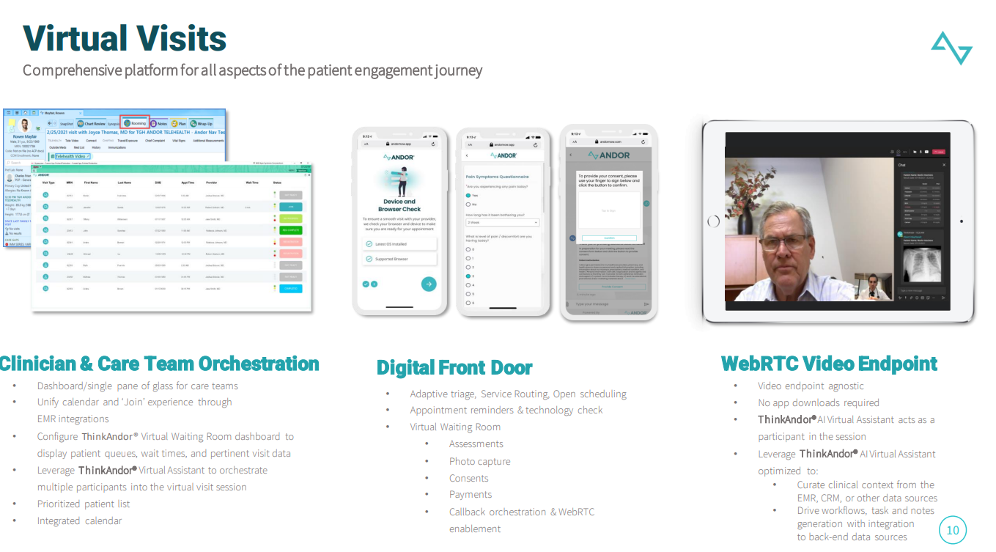
* 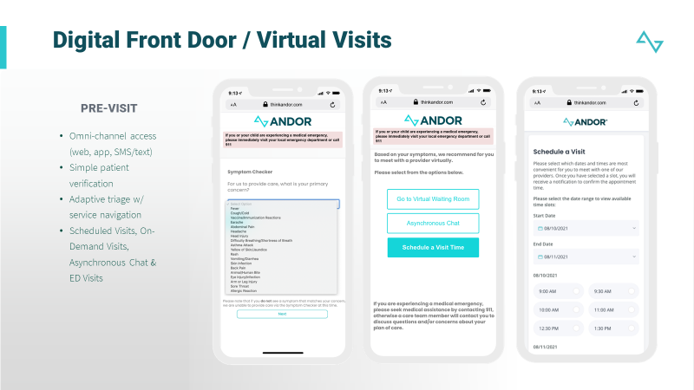
* 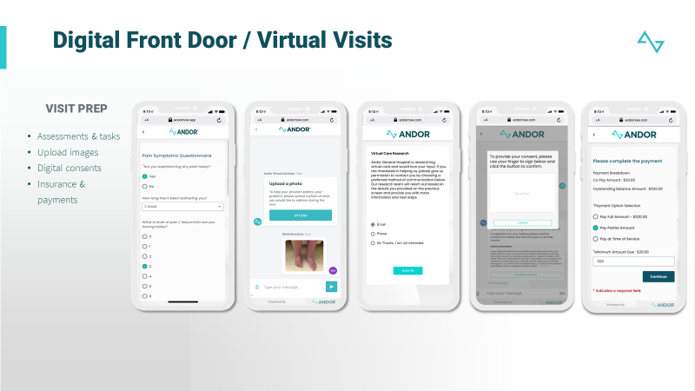
* 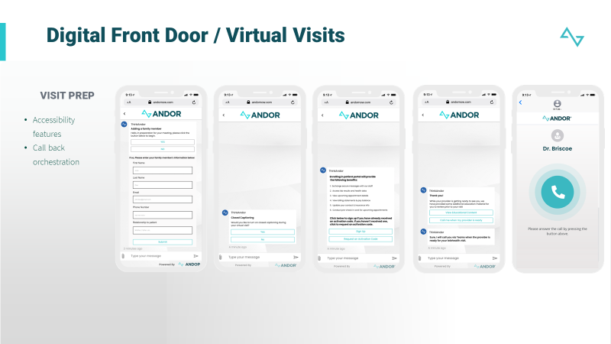

### **3.** **Patient Acceptance**

The solution facilitates receptivity, use, and experience by meeting patient and community members “where they are” using different modalities, e.g., portal, mobile, etc.

ThinkAndor does not require the download of any apps, or username and password in order to access the virtual waiting room experience. An SMS text or email can be delivered to the patient with a secure link and they simply click on rendering a web experience through any browser on any device. Upon entry, ThinkAndor will ask for specific data points, and incorporates a multi-factor authentication mechanism to verify the patient. Once verified, the patient begins their workflow. ThinkAndor pulls the patient details directly from the EHR if they are an existing patient, so the patient simply validates the information as accurate, or gives them an opportunity to edit accordingly allowing for the process to be completed quickly. Over 100 rules of engagement aid in driving an expeditious intake process and ensuring the workflow is highly tailored and efficient for the patient. ThinkAndor includes a complete virtual waiting room experience configured to include intake and triage, signatures, image uploads, consents, payments. Other workflows for check-ins can be instrumented as well.

Andor Health runs a number of adoption and utilization studies on a regular cadence to assess acceptance by distinct populations. These insights are leveraged to further configure optimized experiences across the modalities.

As ane example, our platform has demonstrated less than 1% opt our rates, over 83% engagement rates, and proven a reduction of 30% in readmissions for post discharge follow and remote patient monitoring experiences.

For our Digital Front Door, organizations like SickKids showed significant uptake of the Adaptive Triage capabilities leading to 64% reduction in unnecessary ED visits by navigating patients to virtual primary care and virtual urgent care.

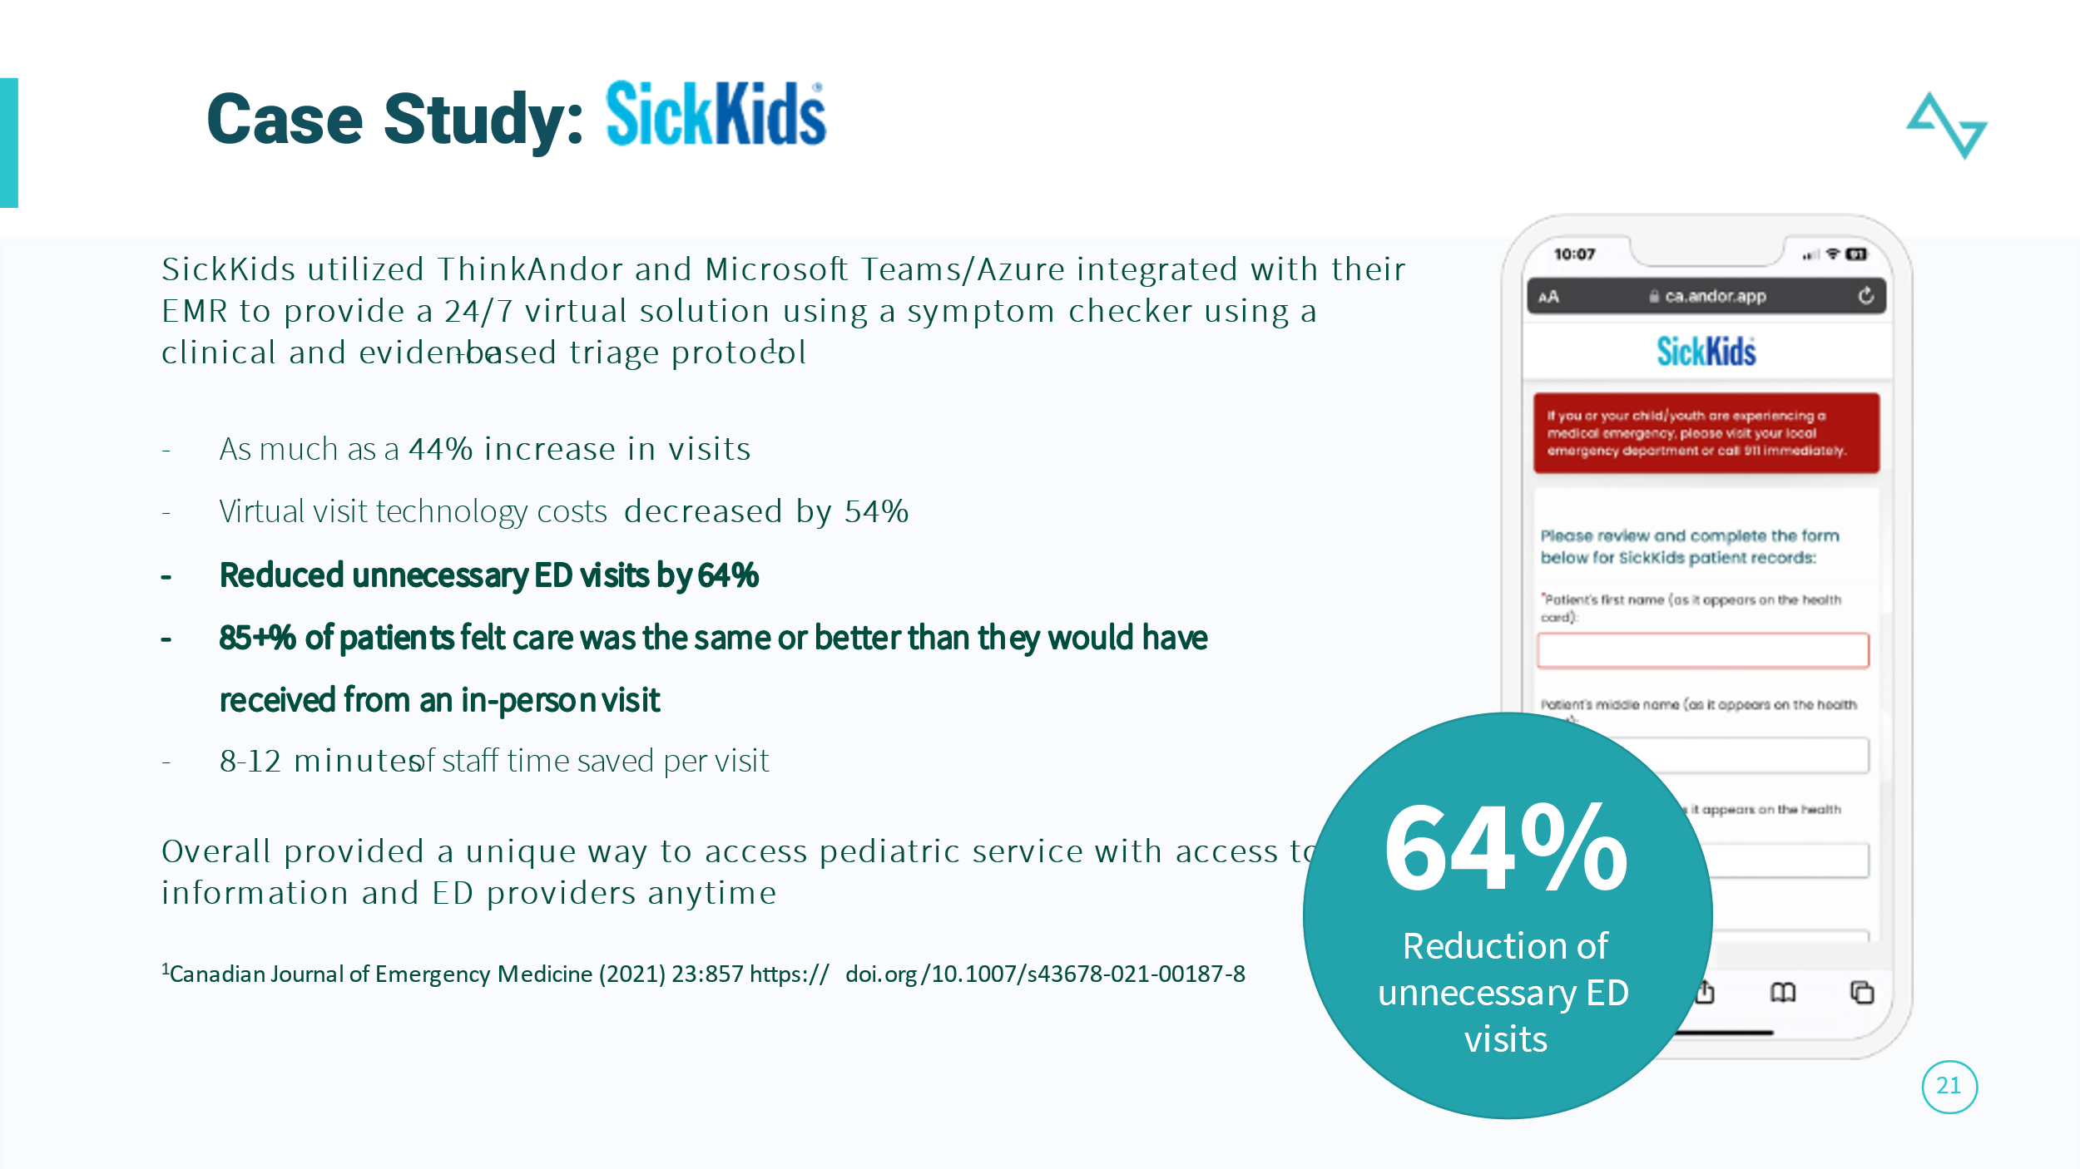





### **4.** **Provider Acceptance**

The solution allows for optimized experience and ease of access for providers to the solution via all modalities, e.g., portal, mobile, etc. Our design team will work with Beebe to determine the appropriate configurations and workflows to ensure an efficient UI for patients and care providers.

The ThinkAndor platform is fundamentally tethered to the health systems EHR, keeping the workflow and data completely intact for clinicians and care teams. Similar to our patients, providers also retain a no app download experience with a single click ‘join’ capability leveraging SSO models with the EHR.

Andor Health leverages a single sign on (SSO) model for seamless authentication between members of the health care organization and the Andor platform. This allows members of Beebe to leverage their existing credentials to connect to the Andor capability.  
The time required to configure and implement our SSO authentication is 1-2 days, we are connecting and linking our accounts with your existing user accounts.

Andor Health continues to work closely with the customer to optimize clinician workflows so they are the least burdensome and highly utilized.

In another case study, published in the Annals of Emergency Medicine, Andor Health demonstrated use of our platform for collaboration between providers in the ED setting. The AI orchestration demonstrated how the platform can capture Triage requests as an order simply placed in the EHR, and actively outreaching only the credentialed, available, and on shift physicians in other facilities to do a virtual triage in a main acute level 1 trauma facility experiencing significant compression in the ED. ThinkAndor employed this ‘uberized’ method to reduce the number of workflow steps by the nurses and clinicians by 40%, improved time to intervention by 30%, and reduced LWBS by 36%.

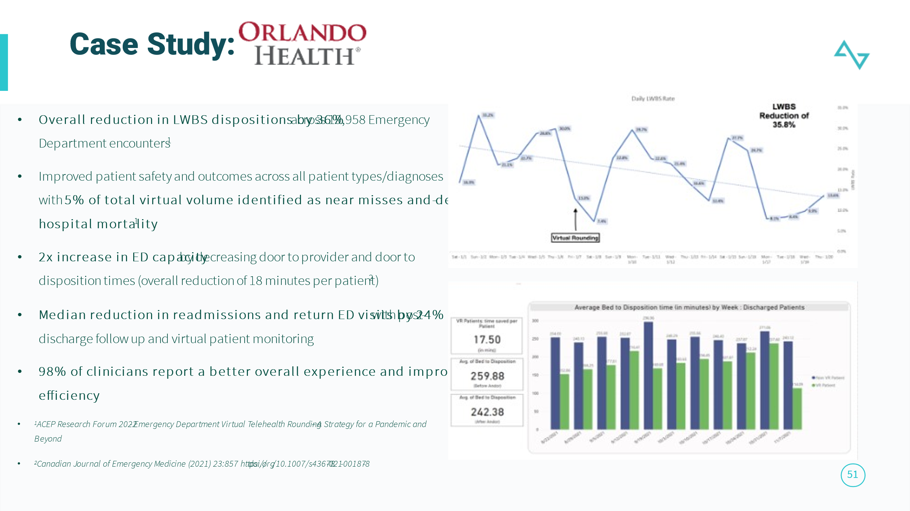

### **5.** **Population Health**

The solution has the ability to provide core functionality that allows the identification, tracking, and managing of clinical information and interventions around a defined population. The ability to integrate a longitudinal record along with notification settings for awareness of clinical change for the population across the Continuum of Care. This solution will be able to then integrate with a data warehouse in order to normalize and analyze information around such a population. This solution will also work with revenue cycle functionality to help manage value-based care contracting tracking, risk adjustment scoring, and ultimately predictive analytics that drive measures of a set population. The solution has functionality to define, track, and manage health on a population basis.

ThinkAndor has robust capabilities for population health management and clinical information integration. It offers core functionality that enables the identification, tracking, and management of clinical information and interventions for a defined population. Here's an overview of the solution's key features:

**Clinical Information Management:** The solution provides the ability to identify, track, and manage clinical information for a patient. This includes aggregating and organizing patient data directly from the EHR, such as medical history, lab results, medication records, and care plans at the point of care.

**Population Health Tracking:** The solution allows for the monitoring and tracking of health-related information and interventions across the continuum of care. It enables healthcare providers to gain a holistic view of a population's health status, identify trends, and implement targeted interventions to improve outcomes.

**Integration with Data Warehouse:** The solution seamlessly integrates with Microsoft PowerBI to normalize and analyze information about the population. This integration enables advanced data analytics, allowing for insights into population health trends, risk stratification, and predictive analytics for better decision-making.

**AI enabled analytics:** The solution leverages AI to drive better outcomes for the defined population. By analyzing real time data, both qualitative and quantitative, patient reported, lab and device data, it can identify high-risk individuals, alert the care team members, and support proactive interventions to improve health outcomes.

Leveraging our data capabilities, coupled with our digital front door experience, ThinkAndor ha been leveraged to outreach patients around specific gaps in care, allowing them to immediately book appointments directly from the outreach. This process has resulted in 40% more gap closures across the enterprise.

### **6.** **Community Care**

The solution contains the ability to track and manage patients across a community Continuum of Care, including enabling patient selection of care modalities, e.g., hospital, clinic, or home. Solution should include the ability to integrate information obtained from community care, e.g., outreach events, vaccinations, etc., into the patients’ longitudinal record in a streamlined format.

**Patient Tracking and Management:** The solution enables the tracking and management of patients as they move across different care settings within the community Continuum of Care. It allows healthcare providers to have a comprehensive view of a patient's care journey, regardless of whether they are receiving care in a hospital, clinic, or home setting through an unified platform approach.

**Care Modality Selection:** The solution empowers patients by automatically bringing the patient into the right care modality, whether it's a hospital for acute care, a clinic for routine check-ups, or receiving care at home for certain conditions. This patient-centric approach enhances patient engagement and satisfaction.

**Integration of Community Care Information:** The solution streamlines the integration of information obtained from the EHR to provide a longitudinal view of the patient at the point of care. This includes data from outreach events, such as health screenings or vaccination campaigns or other data points as necessary.

The ThinkAndor Platform introduces a fundamental pillar called Virtual Community Collaboration. With this pillar, Health systems can further engage physicians in the community that may be affiliated with Beebe. ThinkAndor can identify the patient’s physicians in the community that need to be notified of an admission, discharge, or transfer. ThinkAndor automatically sends a notification via omnichannel outreach to the identified physicians to allow for 100% compliance to the CMS Interoperablity Rule for Conditions of Participation. Moreover, the same capabilitiy allows for the delivery of dischargs summaries, lab results, and other pertinent information required for the community clinicians to continue care.

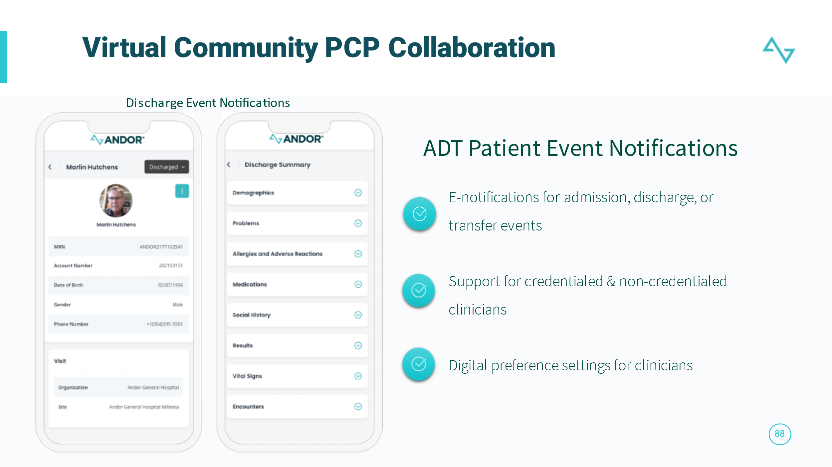

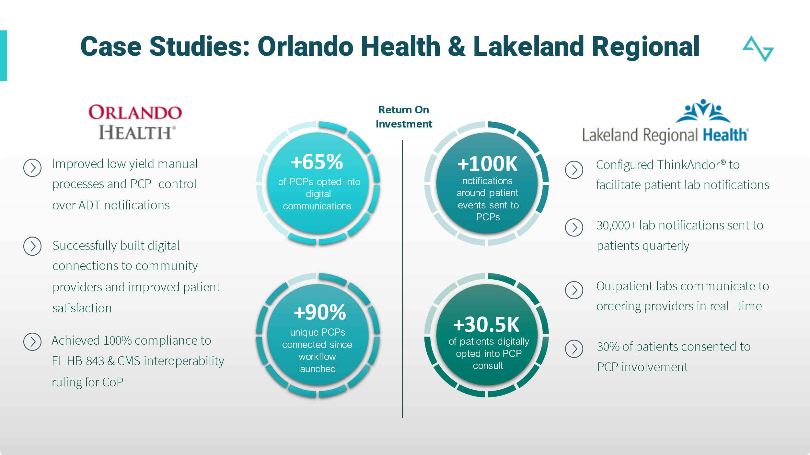

In parallel to Virtual Community Collaboration, with Virtual Patient Monitoring, ThinkAndor also presents a complete post discharge monitoring workflows to send post discharge summaries and assessments to patients and capture any insights along a care plan that might require immediate intervention. This capability has proven to yield a reduction in readmission by over 30%.

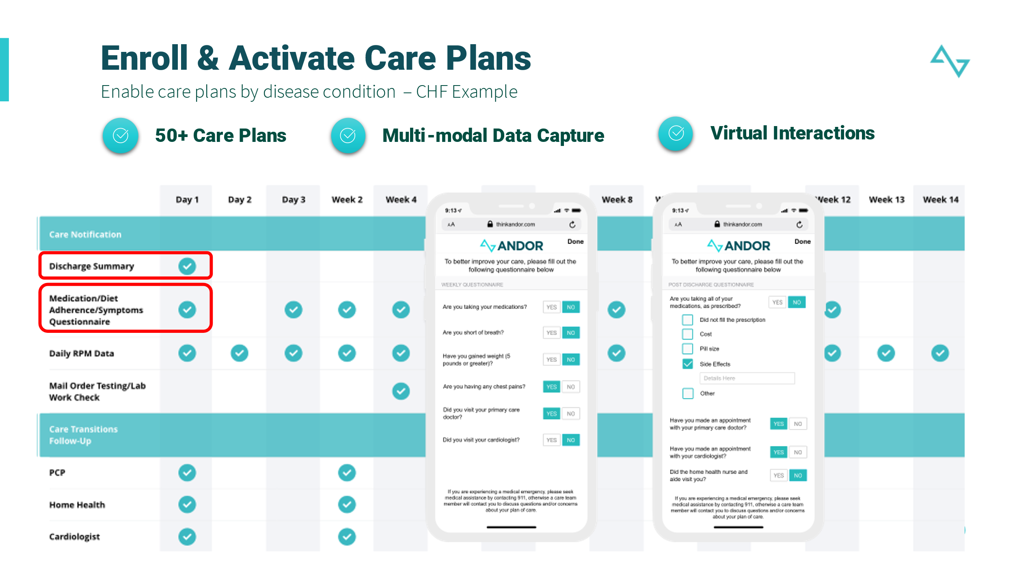

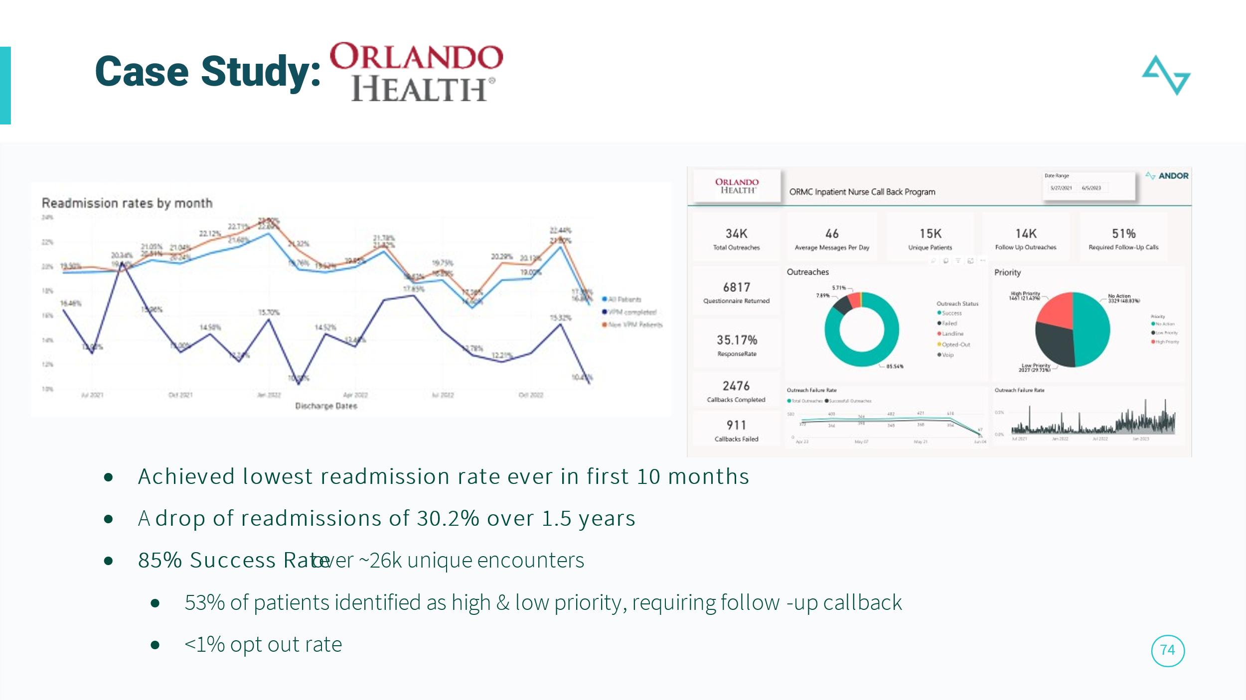

### **7.** **Telehealth**

The solution has the ability to interface with current and future remote monitoring equipment to become a part of the patients’ longitudinal record (as appropriate). This solution should also be able to support functionality that includes internal telehealth services (such as virtual nursing, hospital at home, etc.) and the ability for external telehealth services (such as tele-ICU, etc.).

The ThinkAndor Virtual Care Collaboration Platform is the first to leverage OpenAI/ChatGPT models to enable clinical workflow orchestration and coordination of care across 5 key pillars of Virtual Health across the continuum of care outpatient, inpatient, and at home care environments:

* Virtual Visits – On demand and scheduled access to care both virtual and onsite. Adaptive Triage, provider scheduling, and Virtual Waiting Room experiences are configured to navigate patients through their appropriate journey for on-site or virtual care
* 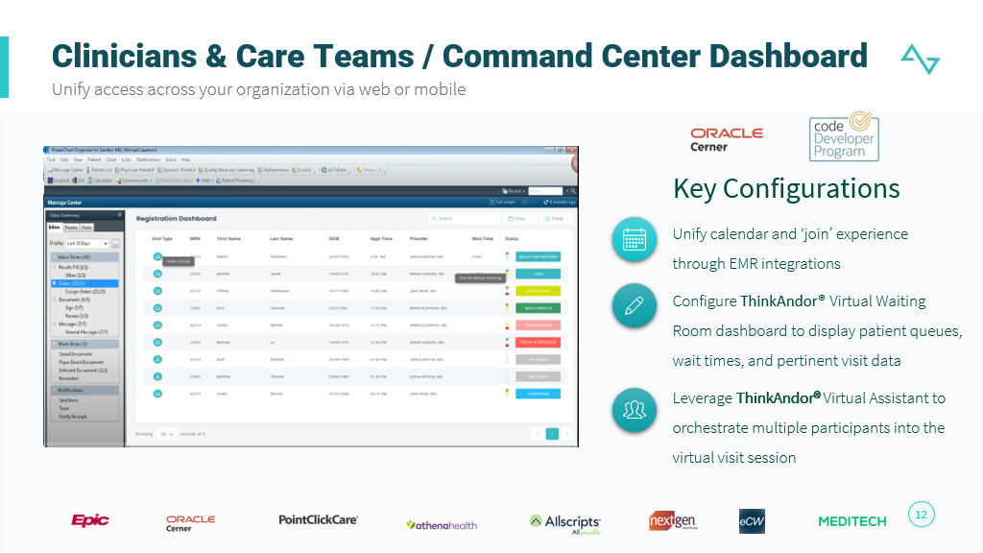
* 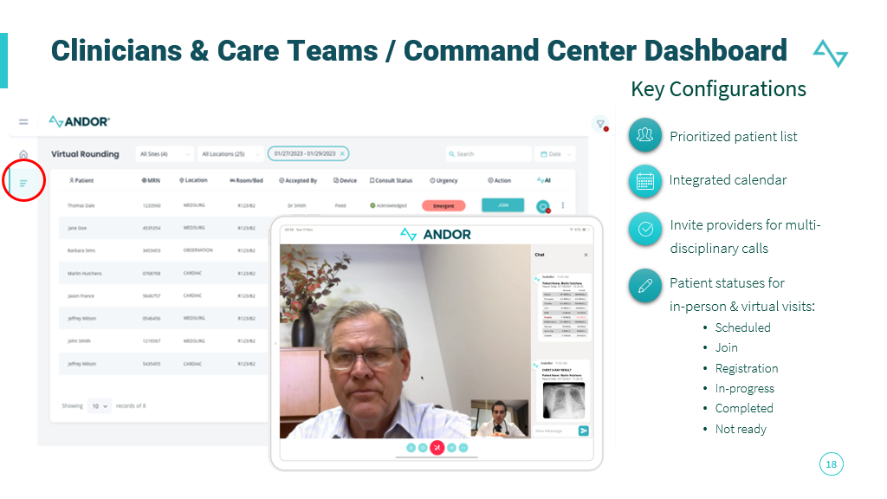
* Virtual Rounding, Nursing and Telesitting – Virtualize in-patient rounding workflows both clinical and non-clinical to address patient experience concerns
* 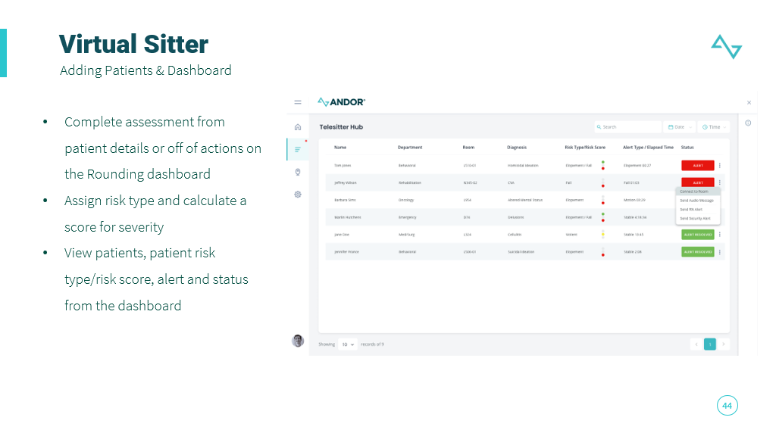
* 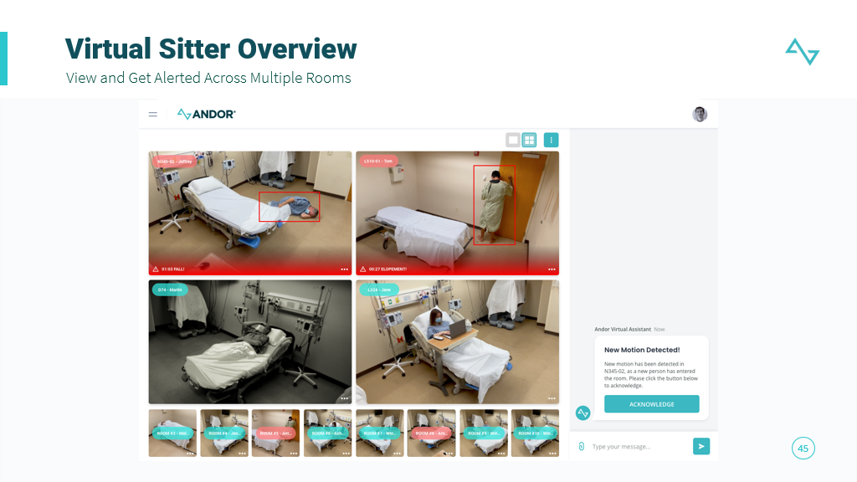
* Virtual Patient Monitoring and Hospital at Home – Monitor patients with 50+ care plans to drive action against care gaps, capture patient self-reported data, and other clinical experiences
* Virtual Team Collaboration – Orchestrate AI Powered secure clinical communications between care team member, drive and enable real time intelligent alert routing to appropriate care team members to optimize population management
* Virtual Community Collaboration – Bridge with secure clinical communication and alerts to community providers to ensure alignment across the care team

Designed with a proprietary role-based hierarchy and enterprise taxonomy, plus Digital Front Door experiences for both the patients and care team, healthcare systems can automate highly efficient workflows that empower clinicians in virtual care delivery. At Andor Health, we believe this ‘virtual clinical workflow layer’ is the crux to solving the most impactful challenges facing healthcare institutions.

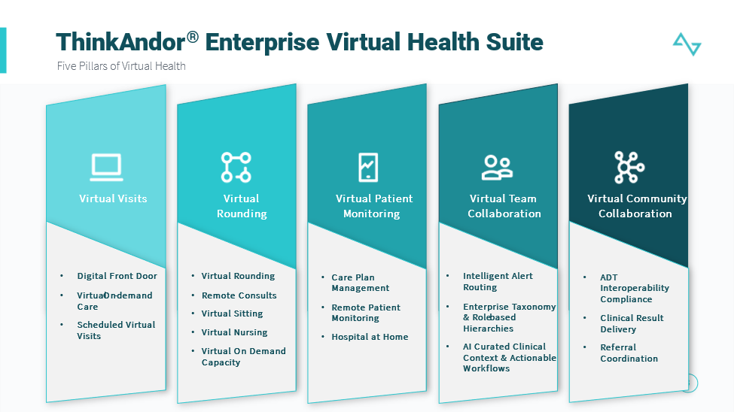

**Virtual Rounding / Virtual Nursing & Virtual Sitting:**

ThinkAndor is the only platform that can **monitor a patient virtually via an AI enabled video endpoints for Virtual Sitting, and simultaneously leverage the same end point for a virtual nursing, virtual consultants and virtual rounding (clinical and non-clinical).** Coupled with ThinkAndor’s AI virtual orchestration, Andor Health supplements technology with nursing and sitting service capacity to support Beebe for a comprehensive Virtual Inpatient Service model that is truly scalable and cost effective.

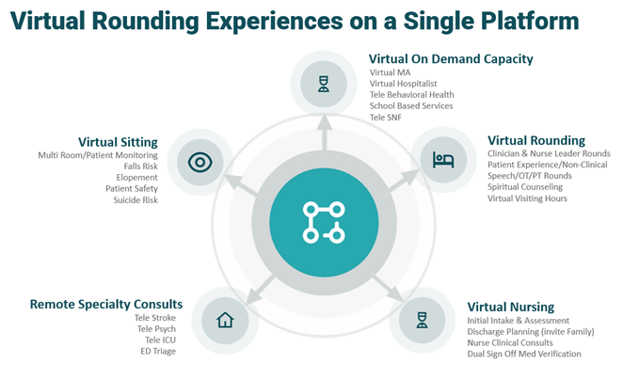

We believe that AI models can support a highly configurable and scalable Virtual Nursing experience, which is now a necessity and has the potential to drive substantial ROI by providing significant reduction in overhead for software and services. Increased patient safety, scalable resources, and time-saving efficiency will be recognized through this partnership. Integration into a variety of endpoints and EHRs will give clinicians and care teams the ability to take action immediately from signals and alerts, all while leading to improved clinical outcomes.

ThinkAndor® brings the next generation of AI based care team collaboration tools that enable a sustainable digital strategy for **Virtual Sitting and Virtual Nursing where we provide a complete turnkey technology and service model that includes software, in room devices with AI, and nurse/tech resources without the need for upfront capital expenditures**. These enhanced experiences are proven to drive substantial ROI by providing a significant reduction in overhead for software and services. Increased patient safety, scalable resources, and time-saving efficiency will be recognized through this partnership.

We at Andor Health are thrilled to present a proposal for a strategic partnership with Beebe. Our aim is to collaborate closely to differentiate Beebe from other healthcare organizations in Sussex County, introduce innovative functionality, bridge existing gaps, optimize workflows, improve patient outcomes, minimize costs, ensure usability and stability, achieve high customer satisfaction, and promote long-term viability. We strongly believe that Beebe can achieve its goal of becoming One Beebe while providing patients with an effortless and user-friendly experience by using ThinkAndor on an Enterprise level and executing on the following initiatives:

* Bring the advanced AI capabilities of the ThinkAndor Platform to enable an EMR integrated Virtual Nursing/Sitting workflow experiences.
* Allow for clinical staff and patient safety observers to monitor multiple patients via one (device agnostic) platform
* Provide highly trained and experienced virtual nursing and sitting resources for added capacity support to Beebe
* Integration of devices including AI driven Pan, Tilt, Zoom (PTZ) camera configuration with integrated far end camera controls.
* Bring a consistent, no app required, experience to patients and providers across devices, browsers and other consumer centric touchpoints.
* Configure our ThinkAndor AI Virtual Assistant, an AI/ML bot feature, to signal appropriate care team member when alert is triggered.
* Enterprise Taxonomy Configuration enabling end to end flexibility for configuration of future workflows and use cases, including Virtual Nursing, Virtual Rounding, and Tele Special Consult and other core systems to enable a seamless user experience.

The scope of our Virtual Nursing and Sitting capabilities will incorporate the following capabilities:

**Virtual Nursing:**

Virtual inpatient rounding/nursing of patients for observation, and from remote locations to hospital bedside with continuous virtual monitoring

* Use Cases may include
  + Intake & Admission
  + Advanced Directives
  + Depression Screening
  + Medication/Allergy Verification
  + Medical/Surgical History
  + Fall Risk Assessment
  + Alcohol/Substance Abuse Screening
  + Diversity/Equity/Inclusion Screening
  + Domestic Violence Screening
  + Care Plan Education
* Inpatient Stay
  + Dual medication verification
  + On demand bedside RN support
  + Call-button management
  + On demand patient assessments
  + Consult management
  + Care transition management
  + Concierge and Patient Experience
* Discharge Planning
  + Safe Discharge Screening
  + Discharge Patient Assessment
  + Designation Discharge Caregiver
  + Patient/Family/Caregiver Education
  + Follow Up Service Confirmation
  + Medication/Pharmacy Review
  + Discharge Follow Up and Readmission prevention
* 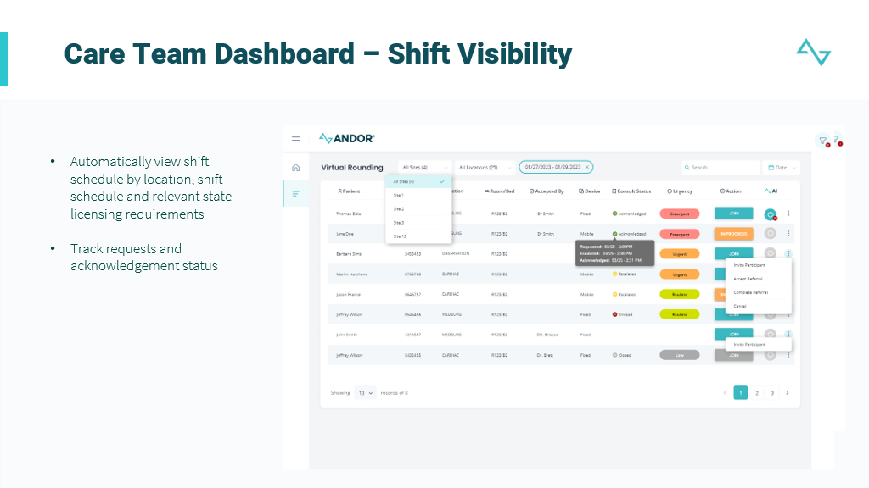

**Virtual Sitting:**

Virtual sitting for simultaneous observation from remote locations to hospital bedside with appropriate alerting and in-room notifications.

Andor provides all Patient Safety Observers and can manage all staffing, oversight, and services. In collaboration with Beebe leadership Andor delivers:

* Workflows for patient identification and enrollment in observation, including inclusion and exclusion criteria and acuity scoring methodology (using highly recognized tools like Morse Fall Score and bCAM delirium assessments, as well as history from the current hospitalization)
* 24/7 request process for the telesitting intervention, with waitlist prioritization
* Clinical inter-team patient reporting process tied to evidenced-based fall safety bundle
* Patient intervention escalation process including communication first with patient, then with clinical staff via all call methodology, then to unit, leadership, and ultimately facility security for activation of response appropriate for acuity of patient behavior.
* Specialized virtual monitoring technician electronic medical record documentation and associated quality and outcome reporting process
* Virtual patient/family orientation to the Services

**ThinkAndor Virtual Collaboration Platform for Virtual Nursing/Sitting:**



The ThinkAndor Platform will include:

* Virtual Nursing & Sitter dashboard with the clinical workflow suitable for effective virtual nursing & sitting
* Virtual simultaneous observations of a least 12 rooms up to 40 rooms in a single view
* Ability to apply/release focus on a single patient in a window
* Andor will provide the hardware, virtual nursing & sitting technology and parts for Bedside Hardware including:
  + AI based PTZ Camera configurations
  + Workstation Cart
  + Monitor & Speakers
* 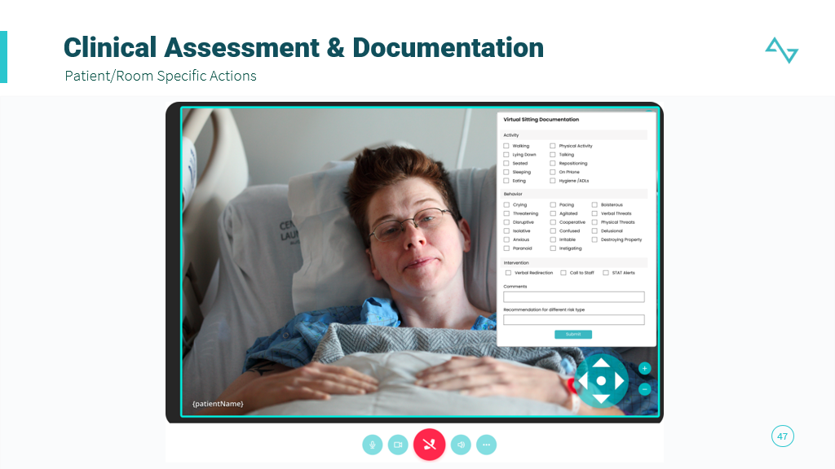
* Integration with Client’s EMR to allow for adding patient to virtual nursing & sitting list and clinician single click ‘join’ experience
* Ability to perform two types of communication with patient:
  + Automated communication initiated by virtual sitter.
  + Normal communication (visual and audible methods) with patient and virtual nurse & sitter
* Reporting *&* Analytics
  + Real-time Power-Bi reports for reporting and Analytics

Andor Health supports our customers by providing Return on Investment metrics and analytics along 3 core dimensions 1) Financial, 2) Clinical and 3) Operational yielding a 3:1 to 4:1 ROI

*Financial*

* Our virtual turnkey nursing and clinical operations and support has shown to reduce nursing resource cost structures by 30%-40% Andor Health provides a full service offering of AI based software, in room devices, and nurse resources with no up front capital expenditure and at a cost structure that is 30% of standard operating cost.
* With the same capability, Andor Health also offers a comprehensive Virtual Sitting service offering helping to reduce the cost of sitting resources by 75%

*Operational*

* Andor Health has demonstrated an increase in nurse capacity of 30%-40% supporting various use cases including Dual Med Verification, Discharge Planning, Intake & Admission, and many other use cases
* Leveraging virtual nursing and virtual rounding experiences in the ED, we have demonstrated a reduction in Left Without Being Seens (LWBS) by over 17%, in addition to increasing ED Capacity by 2x
* Andor Health has also demonstrated a 20% improvement in timely discharge, and 10% reduction of length of stay and readmission
* Leveraging our virtual nursing capabilities has allowed client nurse staff to focus on higher acuity patients and allowing them to practice at top of license resulting in 35% reduction in staff burnout
* Other metrics include:
  + Decrease agency work by 20%
  + Decrease turnover / vacancy rate
  + Improve specific nursing engagement indicators associated with safety culture (resources and teamwork; prevention and reporting domains)
  + Decrease labor cost per unit of service by 10%

*Clinical*

* 50%-70% reduction in Falls Risk
* 10% reduction in Length of Stay
* 24%-40% reduction in readmissions
* 5% of total volume in ED identified as patient saves and decreased hospital mortality
* Other metrics include:
  + Improve core measure outcomes for sepsis
  + Decrease hospital acquired infection rates associated with CAUTI and CLABSI in intervention units
  + Improve patient throughput in intervention units by 10%
  + Improve patient satisfaction with nursing engagement as evidenced by specific HCAHPS domains (communication with nurses; discharge information) by 5%

With the implementation of ThinkAndor’s 5 pillars, our customers have successfully achieved the following results:

* 64% reduction in unnecessary ED visits by navigating patients to the best level of care
* 35% decrease in visit abandonment & no-show rates
* Adding 4-6 new consults a day per specialty using our Digital Front Door capability
* 40% more care gaps closed
* 20% improvement in timely discharge
* 10-12 minutes saved per visit when patient insights are captured during the virtual waiting room experience
* 17% reduction in left without being seen rates (LWBS)
* Saving over $15M in costs on average for medium to large sized hospitals
* Cutting staffing costs related to hospitalists and specialty providers in half for health systems
* 60% reduction in sitter costs
* 35% reduction in physician burnout
* 100% compliance with CMS interoperability requirement

**Virtual Patient Monitoring:**

Andor Health brings a platform approach leveraging the ThinkAndor Virtual Patient Monitoring module. The capabilities include of this module include:

* Over 50+ configurable care plans across different care environments, populations, and condition types including, but not limited to:
  + Cardiovascular & Metabolism
  + Immunology
  + Infectious Diseases & Vaccines
  + Neuroscience
  + Oncology
  + Pulmonary Hypertension
* Patient self-reported assessments and personalized care plans provide both qualitative and quantitative intelligence to care teams monitoring patients
* Distinct signals and alerts to clinical care teams based on distinct data points or trending information about the patient themselves.
* ThinkAndor AI Virtual Assistant powered by OpenAI/ChatGPT technology aids in recommending next best actions to care teams including virtual visit interactions, asynchronous chat, or multi-disciplinary interactions
* AI driven SOAP note creation and clinical documentation
* EMR and CRM integrated workflows including Salesforce.com
* Enterprise taxonomy and role-based hierarchy allows for distinct configurations and intelligent routing and escalations of patient events and alerts
* Initiation of specific interventions that can be taken by the care team members.
* Extension to other virtual scenarios. Virtual health involves not only remote patient care management and care coordination but changing the model for various patient interactions – from the complete digital front door with symptom checking and triage, virtual visits, post visit follow up and surveys, education delivery, and multi-disciplinary team collaboration. Andor on the Microsoft platform enables Beebe to deliver a solution that meets the needs of today and providing a framework to extend for many years to come
* Ability to leverage 3rd party clinical care teams, yet also provide additional capacity for nursing and care team resources to supplement existing team.
* Omni channel communications both, automated along the care plan, and on demand by care teams via SMS Text, Email, WhatsApp, and secure chat.
* Integrated asynchronous/synchronous virtual visit experiences for interventions and routine patient follow up
* Multilingual capabilities, including Portuguese and Spanish platform translation
* Andor Health also brings additional service line support with over 1400 nurses to provide Janssen with burst capacity needs
* Full white labeling and branding for clients
* No app download required by patient population

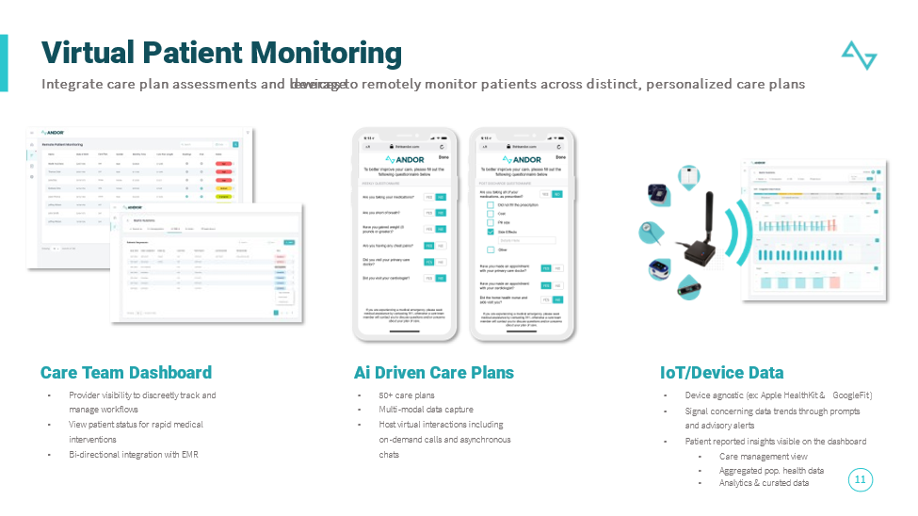

**Care Plans**

We support over 50+ care plans with our platform and many patients are supported successfully in more than one at a time. Our platform allows for combined care plans for patients with comorbidities, and rapid configuration of subpopulation care plans that require more intensive management. Organizations can even configure and adjust their own care plans with no code/low code environment.

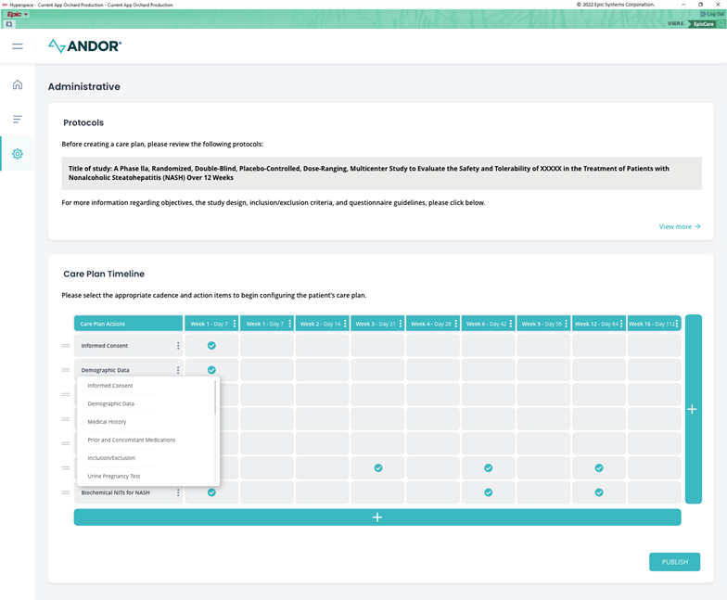

Regardless of the stage/severity of their condition, our services fit naturally within their overall comprehensive care plan, so the patient has a very cohesive experience as opposed to different outreaches in different care plans that appear misaligned. Even during an acute event or admission, we have the capability to keep remote patient monitoring care teams up to date on the patient’s status and disposition, and allow them to pause/stop programs, start/restart patients at a specific point in the care plan, and other functions that tailor the experience.

**Devices:**

ThinkAndor provides a complete device kitting for the patient populations that is geared toward distinct care plans like CHF. However, our platform is also device agnostic and not restricted to any specific manufacturer of devices. With our device aggregation hub and integration to Azure IoMT hub, patients and/or their healthcare providers use any variety of devices allowing us to support those, even in low bandwidth and areas where Wi-Fi is not supported.

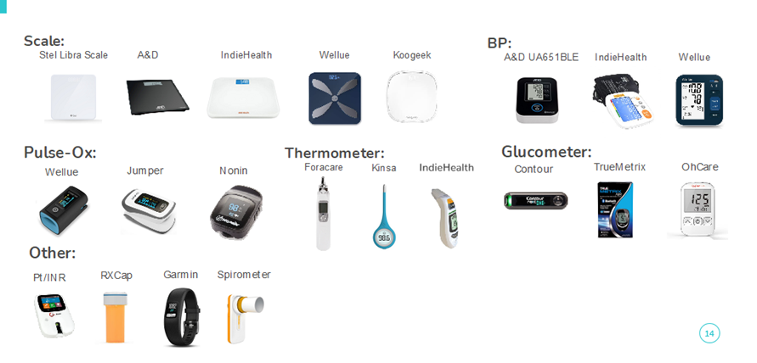

**Care monitoring:**

ThinkAndor is able to ingest data from specific data sources including the EHR for clinical context, biometric device data for quantitative data, and patient self-reported assessments along the care plan that provide qualitative data points allowing our platform to identify patient risk for care managers. Clinical protocols and trends are leveraged to identify the risk, route patient alerts to different care team members, and recommend an appropriate course of action/intervention. These interventions can include initiating on demand/scheduled virtual visit experience, asynchronous/synchronous chat, or educational content that might be relevant to the patient.

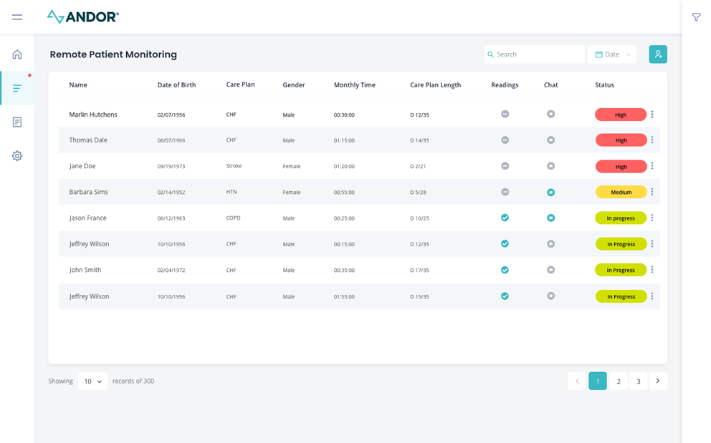

Care Teams are able to review patient chart details including medications, biometric device data with historical analytics, and patient self-reported outcomes. And ThinkAndor AI Virtual Assistant is able to record each interaction with the patient and time spent reviewed on the chart to help with accurate calculations of appropriate billing codes for RPM services.

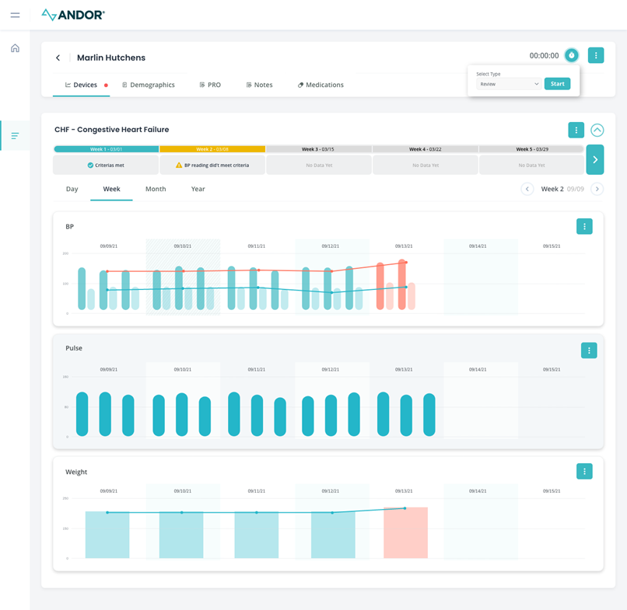

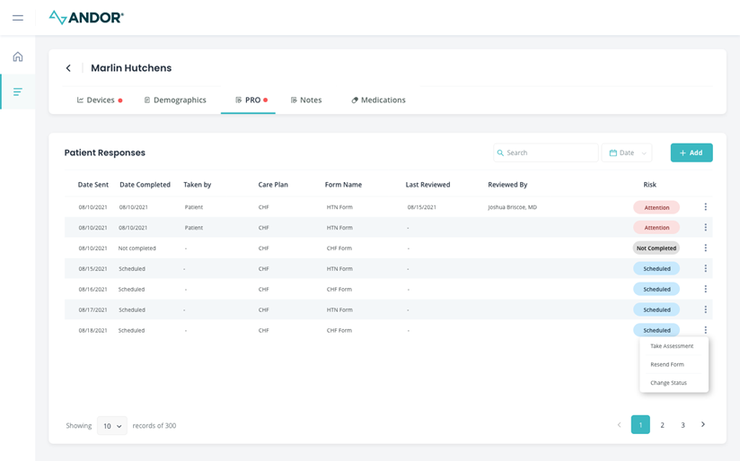

Patients are navigated across their care plan by the ThinkAndor AI Virtual Assistant that will navigate the patient along their own distinct care plan. Through omnichannel outreach SMS Text, Email, WhatsApp, or other channel, ThinkAndor presents distinct actions/nudges to the patient that is a required task (s) for the day. ThinkAndor is also designed with over 100 rules of engagement to identify the most optimal timeframe, modality, and cadence to outreach the patient for that action to be performed. There is no download of any app required by the patient making the experience highly engaging and simplified regardless of geography, location, or population type.

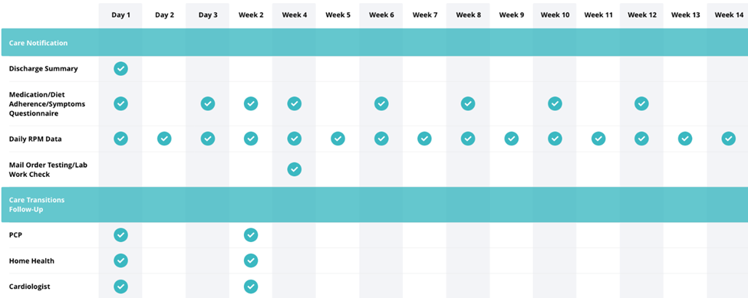

The automation that ThinkAndor has been able to provide for health systems has been published and well documented. Some example metrics include:

1. No app download and ease of use decreased the amount of patient time spent onboarding by 25%
2. **20% additional billing hours** captured with automated time tracking
3. **5 hours saved monthly** per patient of nurse & administration time
4. **3X patients monitored** without increasing provider resources
5. **1.5 days saved** monthly on billing data collection & reporting
6. **< 1% Patient Opt Out rate with over 82% patient engagement rate**
7. **Demonstrated and published reduction in readmission rates by over 24%**

* **8.** **Mobile Accessibility**

The ability to access the patients’ longitudinal record in a secure yet diverse mobile ecosystem using the full spectrum of mobile capabilities, e.g., phones, tablets, etc., via voice and/or keyed interaction.

The Andor Health platform is device, browser, and technology agnostic. This allows for a simple 'join' experience for the end user. While Microsoft Teams can be leveraged for audio, video, and chat collaboration, visit interactions require no app downloads and can be done via WebRTC. The platform is compatible with any operating system, browser, or device that is used by the provider. The Andor Health platform also has the capability to integrate to a variety of free floating, in room, or cameras and IoMT devices. Moreover, the Andor Heath platform is designed to be omni-channel allowing for communication to occur via SMS Text, Email, Teams, or any combination thereof.

### **9.** **Third Party Utilization**

The extent to which the solution involves the use of third-party technologies and the degree to which they are fully integrated with the core solution versus external additions, i.e., bolt-ons. Identify third parties included in your quote.

Andor Health uses Microsoft Azure for our cloud services. We do not use any other third party solutions.

### **10.** **Advanced Technologies**

The solution’s current and planned use of advanced technologies, e.g., bots, robotic devices, artificial/augment intelligence (AI), integrated patient wearable devices, etc., including “plug and play” of future technologies.

* The ThinkAndor Virtual Care Collaboration Platform is the first to leverage OpenAI/ChatGPT models to enable clinical workflow orchestration and coordination of care across 5 key pillars of Virtual Health across the continuum of care outpatient, inpatient, and at home care environments. ThinkAndor is an open architecture platform that allows for easy pluggability of other platform capabilities both at a software and hardware level. For Virtual Rounding, Andor Health can allow for any in room devices to be leveraged by Beebe and will seamlessly plug into the ThinkAndor Platform. For Remote Patient Monitoring, Andor Health allows for any set of devices to be leveraged by the patient population to monitor at home.

:

* Virtual Visits – On demand and scheduled access to care both virtual and onsite. Adaptive Triage, provider scheduling, and Virtual Waiting Room experiences are configured to navigate patients through their appropriate journey for on-site or virtual care
* Virtual Rounding, Nursing and Telesitting – Virtualize in-patient rounding workflows both clinical and non-clinical to address patient experience concerns
* Virtual Patient Monitoring and Hospital at Home – Monitor patients with 50+ care plans to drive action against care gaps, capture patient self-reported data, and other clinical experiences
* Virtual Team Collaboration – Orchestrate AI Powered secure clinical communications between care team member, drive and enable real time intelligent alert routing to appropriate care team members to optimize population management
* Virtual Community Collaboration – Bridge with secure clinical communication and alerts to community providers to ensure alignment across the care team

Andor Health's innovative platform, ThinkAndor®, leverages open AI and healthcare-trained ChatGPT models to enable care teams and patients to connect anywhere across the care continuum. By unifying virtual health into one cohesive platform, ThinkAndor® enables the entire health system to virtually provide care at scale.

It is also notable that Microsoft is a strategic partner, and we are a portfolio company of Microsoft. The Andor Health platform introduces the only role-based hierarchy and enterprise taxonomy which is highly configurable by healthcare institutions in a no code/low-code environment. We also believe clinical workflows should be highly configurable. Allowing for an omni-channel approach which is curated and personalized to the end user and can provide a suitable pathway for care. The advantage of using a modern communication platform is receiving benefit from all the advanced AI features that can enable virtual health to be rich and full featured.

### **11.** **Integration**

The solution’s ability to easily and seamlessly integrate solutions and devices (planned and ad hoc) using which (preferred and available) methodologies, e.g., HL7, API, FHIR, etc.

Andor Health supports and can integrate across multiple EMR systems, including Allscripts, CERNER, EPIC, Athena Health, EMIS, Meditech, and other EMR systems through HL7 v2, FHIR, Native APIs. This integration can be leveraged to pull curated clinical data directly from the EMR, as well as orders that can be placed back into the EMR as workflows are scoped, defined, and required by the customer.

### **11.** **Data Analytics**

Describe the ability for real-time, prospective, and retrospective data analytics offered by the platform.

Andor Health can make performance / operations reports as per the need of the client. We can configure automated reports which includes statistics such as user success rates, failure rates, utilization rates, etc. which could be made available real time. We have the ability to create custom reports using PowerBI to meet the client’s requirements. Standard reporting functionality is included in the pricing.

ThinkAndor Platform has an built in analytics and reporting configurable through PowerBi. Analytics captured include operational reporting, patient engagement metrics, clinical outcomes, and billing. Andor Health can make performance / operations reports as per the need of the client. We can configure automated reports which includes statistics such as user success rates, failure rates, utilization rates, etc. which could be made available real time. We have the ability to create custom reports using PowerBI to meet the client's requirements. Standard reporting functionality is included in the pricing.

With ThinkAndor, we leverage our AI capabilities and over 100 rules of engagement to tailor the engagement model to the patient allowing us to capture higher levels of both adoption and utilization. As mentioned, we have proven less thatn a 1% opt out rate, and over 82% engagement rate across the population we serve.

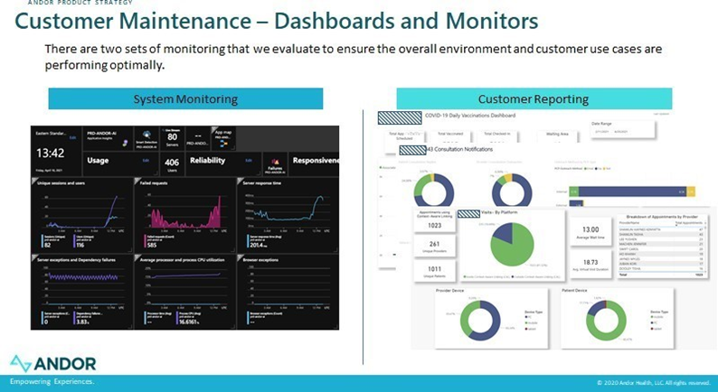

### **12.** **Cybersecurity**

Solution adheres to and complies with cybersecurity regulations and best practices of HIPAA/CFR Title 45 and/or NIST Standards as well as Federal, State and local guidelines to include being supported by an internal security team.

The solution does not host data onsite and we leverage Microsoft Azure for SOC 2, HITRUST, and HIPPA requirements. Privacy is built into the Azure infrastructure, governed by Microsoft privacy policies and the Microsoft Privacy Standard, the cornerstone of the Microsoft privacy program. Details at <https://azure.microsoft.com/mediahandler/files/resourcefiles/microsoft-azure-compliance-offerings/Microsoft%20Azure%20Compliance%20Offerings.pdf>.

### **13.** **Processing Environment**

What options, e.g., cloud, hosted, on-prem, etc., exist for processing, noting preferred and available options?

Andor is a cloud-based solution with the ability to scale quickly in the event that bandwidth issues become problematic. Hosted on Azure, we have complete redundancy and failover to other Azure regional instances. We also provide hosting / on-prem options if required by the client.

### **14.** **Implementation Approach**

What are the preferred and available alternative implementation approaches, e.g., big bang, phased, etc., including justification for that preferred approach and a description of the transition approach from current to future state?

The preferred implementation approach for our company's solution is a phased implementation strategy. This approach involves breaking down the implementation process into distinct phases: Requirements Gathering, Integration and Configuration, Testing and Training, and Go-Live. The phased approach allows for flexibility and adaptability, as each phase can be adjusted based on the specific needs and priorities of the organization. It also enables the organization to gradually transition from the current state to the future state, minimizing disruptions and optimizing the adoption of the new solution.

The implementation process starts off with a kickoff call comprised of Andor's project manager, project stakeholders, and other key project personnel to discuss roles and responsibilities and overall project timeline and milestones. The Andor Project Manager will set a weekly meeting with the Client's project manager to review weekly deliverables and ensure both teams stay on track to meet the milestone dates. If the Client proposes any scope changes, Andor's project manager and Business Analyst will capture the requirements as provided by the Client and review the business requirements with the Andor development team. The Andor Project Manager will communicate to the Client pertaining to the timeline to implement such scope changes and provide an updated SOW if applicable.

Once the requirements and timeline have been established, the Andor integration analysts will work with the Client’s integration team. Depending on the scope defined, integration tasks may include establishing VPN connection, enabling single sign on, interface configuration, and integration with third party systems, etc. The Data Analysts will then analyze and map the data to the Andor platform accordingly. Andor’s configuration specialists will work on configuring the Andor platform according to the requirements defined by the Client.

Training will start as soon as all the changes are made to the test environment and the client has successfully completed testing and has accepted the results. Training, like testing, can be as frequent and as many as necessary. The product managers will prepare a customized training document for Beebe team and will include screenshots that are specific to Beebe. The project manager will coordinate a Go-live date based on the client’s preference, allowing necessary time for thorough testing and training. Andor Health, like mentioned earlier, will conduct a train-to-trainer approach, and provide supplemental training materials and user guides to support the Client. There will be training test scripts and detailed step by step user manuals provided to the Client.

### **15.** **Implementation Timeframe**

Using the preferred implementation approach, what is the expected implementation timeframe along with the range from best to worse case?

The implementation timeframe will depend on the use case(s) and the organization's existing systems Andor will need to integrate with. However, Andor's typical implementation for a customer the size of LifePoint with an out of the box use case functionality is 4-6 weeks. This includes 1-2 weeks for gathering requirements, 2-3 weeks for configuration and integration, 1-2 weeks for testing and training and then go live and support.

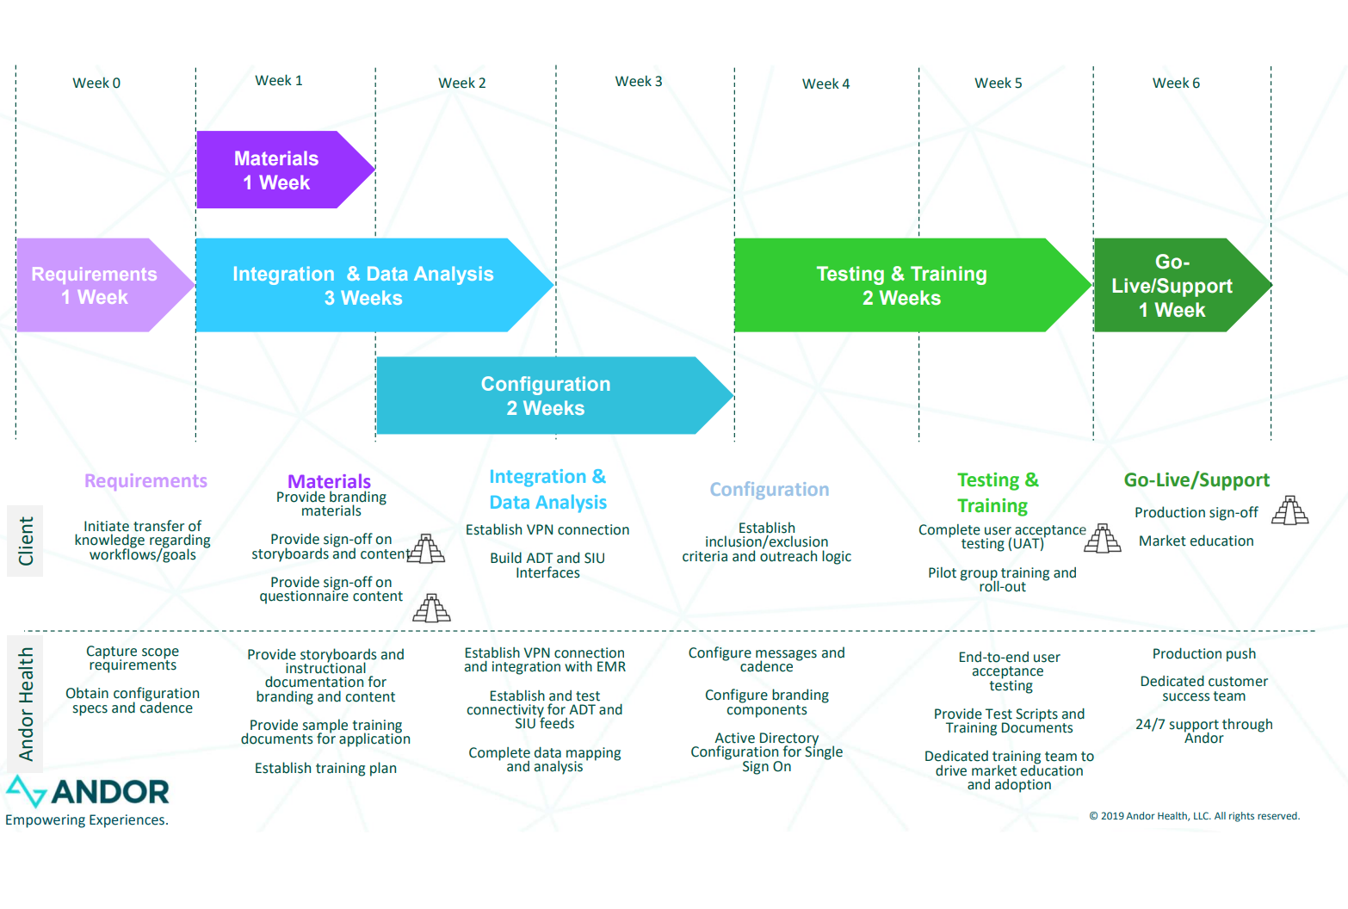

### **16.** **Implementation Risk**

Supported by actual empirical results, what percentage of solution implementations were achieved within the originally estimated time and budget?

All implementations have been achieved based on the mutually agreed timelines that are discussed with each customer prior to and during the implementation process. We work closely with the customer in the event there are unplanned system changes they have not accounted for, and adjust accordingly to meet the optimal capabilities for go-live

### **17.** **Operational Disruption**

Describe the estimated degree and duration of operational disruption Beebe is likely to experience during implementation of your solution, along with the range from best to worse case.

There will be little to no operational disruption during our implementation. Since we are a complete software as a solution platform, all our use cases get rolled out seamlessly and integrated with existing solutions.

### **18.** **Vendor Implementation Support**

Describe the degree to which you will provide implementation support.

Andor Health team will provide support throughout the implementation process and post go-live.

The Implementation consists of four phases (1) Requirements Gathering (2) Integration and Configuration (3) Testing and Training (4) Go-Live. A sample high level timeline is provided below to illustrate our process.

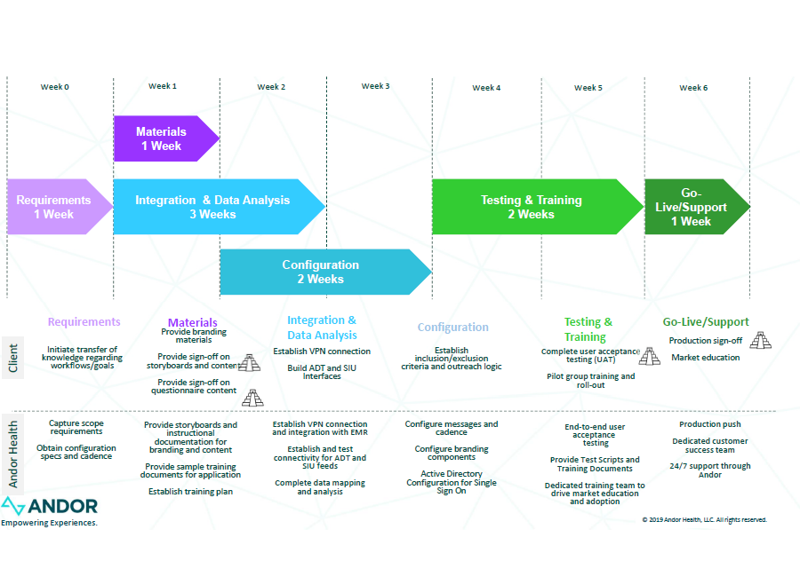

Our implementation team is led by our project manager who will work with the Client to establish timelines, roles, development process, project milestones and tasks. The project manager will be responsible for coordinating meetings with the Andor Health and Client teams, providing updates to stakeholders, and ensuring the project is on track to meet milestones and deliverables.

Training will start as soon as all the changes are made to the test environment and the client has successfully completed testing and has accepted the results. Training, similar to testing, can be as frequent as necessary. We will train the trainers but also have the bandwidth to train providers, as per the client’s necessity. The product managers will prepare a customized training document for the client and will include screenshots that are specific to the client. The project manager will coordinate a Go-live date based on the client’s preference, allowing necessary time for thorough testing and training. Andor Health, like mentioned earlier, will conduct a train-to-trainer approach, and provide supplemental training materials and user guides to support the Client. There will be training test scripts and detailed step by step user manuals provided to the Client.

Moreover, Andor Health leverages an Agile development process to drive continuous development that supports new feature rich capabilities, security upgrades, new device integrations, and other system interfaces which allows for rapid development and expedites time to market.

### **19.** **Beebe Implementation Support**

Using the preferred implementation approach, what level of Beebe resources will be required for implementation?

The Beebe resources outlined do not need to be full time, and/or dedicated to the rollout of the pilot. They will be utilized only as needed, and Andor Health will provide resources to augment any unavailable member of the Beebe team.

Our typical implementation will include the following team members from the client side.

- Project Manager

- Integration specialist

- Infrastructure specialist

- IT support

- Clinical resources as needed

### **20.** **Beebe Ongoing Support**

What level of Beebe resources will be required to support your solution on an ongoing annual basis?

Support and maintenance will be entirely managed by Andor Health. The solution provides a standard SLA for support services with all customers. Andor Health shall maintain a help desk to receive service-related inquiries from the client during business hours. Andor Health will provide the client extended support outside of Business Hours for Critical Issues.

### **21.** **Total Cost of Ownership**

Itemize the solution’s total cost of ownership (TCO) including both one time and recurring costs. Detail should include costs associated with labor, software, infrastructure, implementation fees, integration, end user devices, etc., as well as subscription-based, maintenance and annual fees. Specify if costs are vendor only or inclusive of other parties, i.e., third parties, consultants, etc. Where costs cannot be precisely provided, indicate cost range(s), identifying best case, worse case, and most likely case.

Andor Health offers a standard subscription model based on the modules contracted for by the customer. Generally, inpatient modules are per facility per month, while outpatient modules are per provider per month. Enterprise license and volume based options are also available. A one-time implementation fee will also be assessed for configuration, integration and training.

**One time costs:**

Implementation fee:

**Recurring costs:**

Annual Enterprise licensing fee:

### **22.** **Vendor Viability**

Describe your plan to maintain this solution as viable and supported for the next 3, 5, and 7 years. Include your plan to continually evolve and enhance the solution.

Andor's platform is a SaaS platform that is continually updated to take advantage of new capabilities from devices, video technologies and 3rd party integrations. Andor has chosen an agnostic approach to integrate devices, video platforms, AI technologies, cloud capabilities to ensure the greatest flexibility and extensibility as new innovations come to light. By encapsulating your workflow in Andor you enable configuration based changes to accelerate innovation.